JENKINS TASK 04
- Setup Jenkins CICD pipeline using freestyle job using Docker containers using below code. https://github.com/betawins/hiring-app.git Stages:
  - Git Clone
- Create ne job seect source git paste the repo url
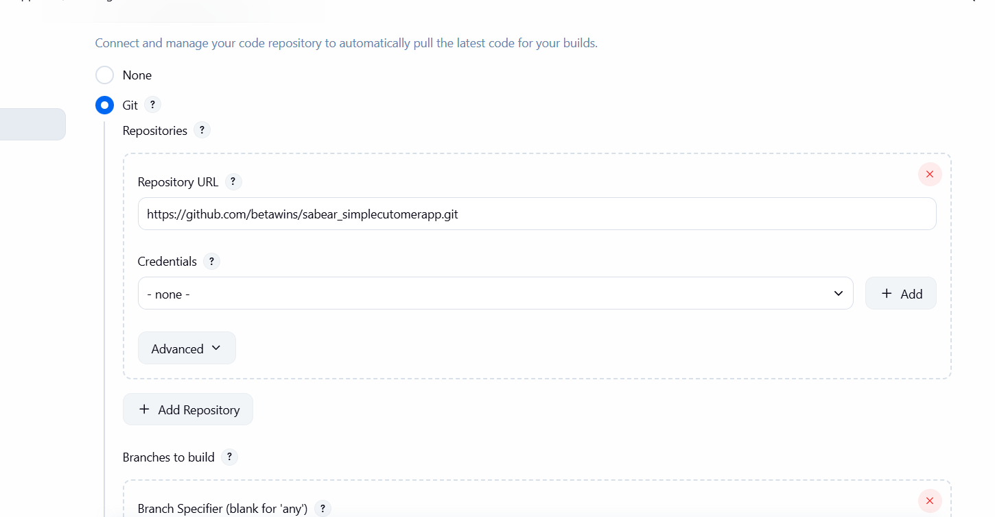
build the job it will clone the repo
note : install git in the machine also – yum install git
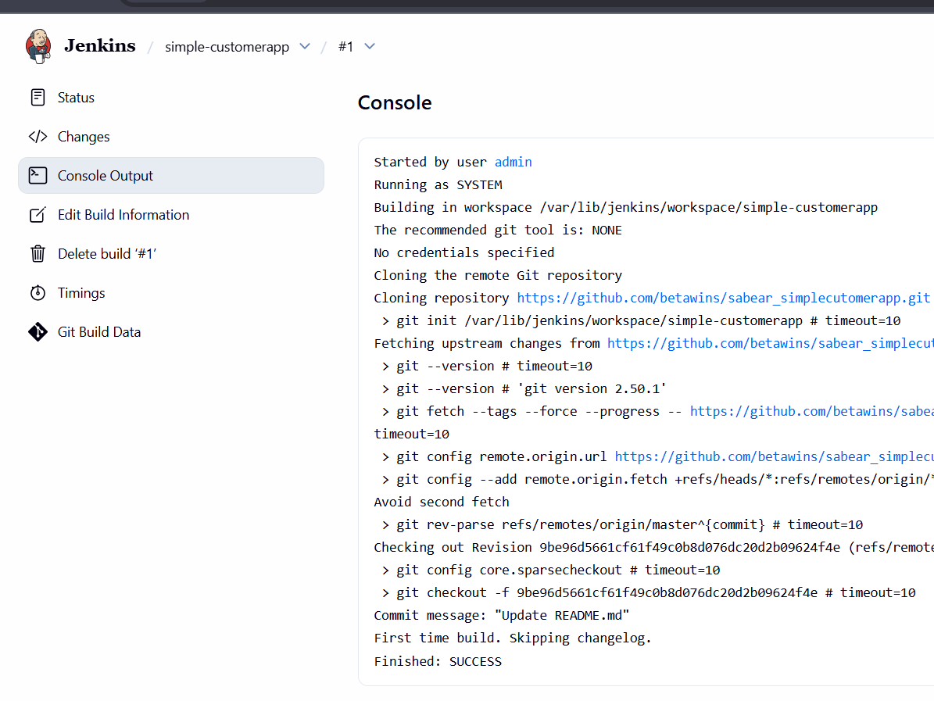

  - SonarQube Integration
lauch instance with the instance type t3.large or other large 20 gb of volume
connect to the server
yum install java-17
yum install docker
systemctl start docker
systemctl enable docker
docker pull sonarqube:10.3-community
docker run -itd -p 9000:9000 sonarqube:10.3-community
check it in the browser
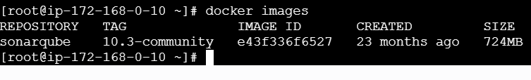
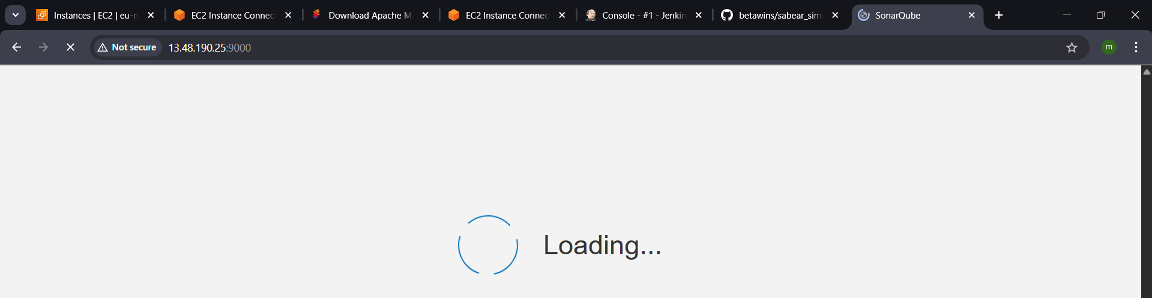
Default user : admin ; password -admin
Change the password
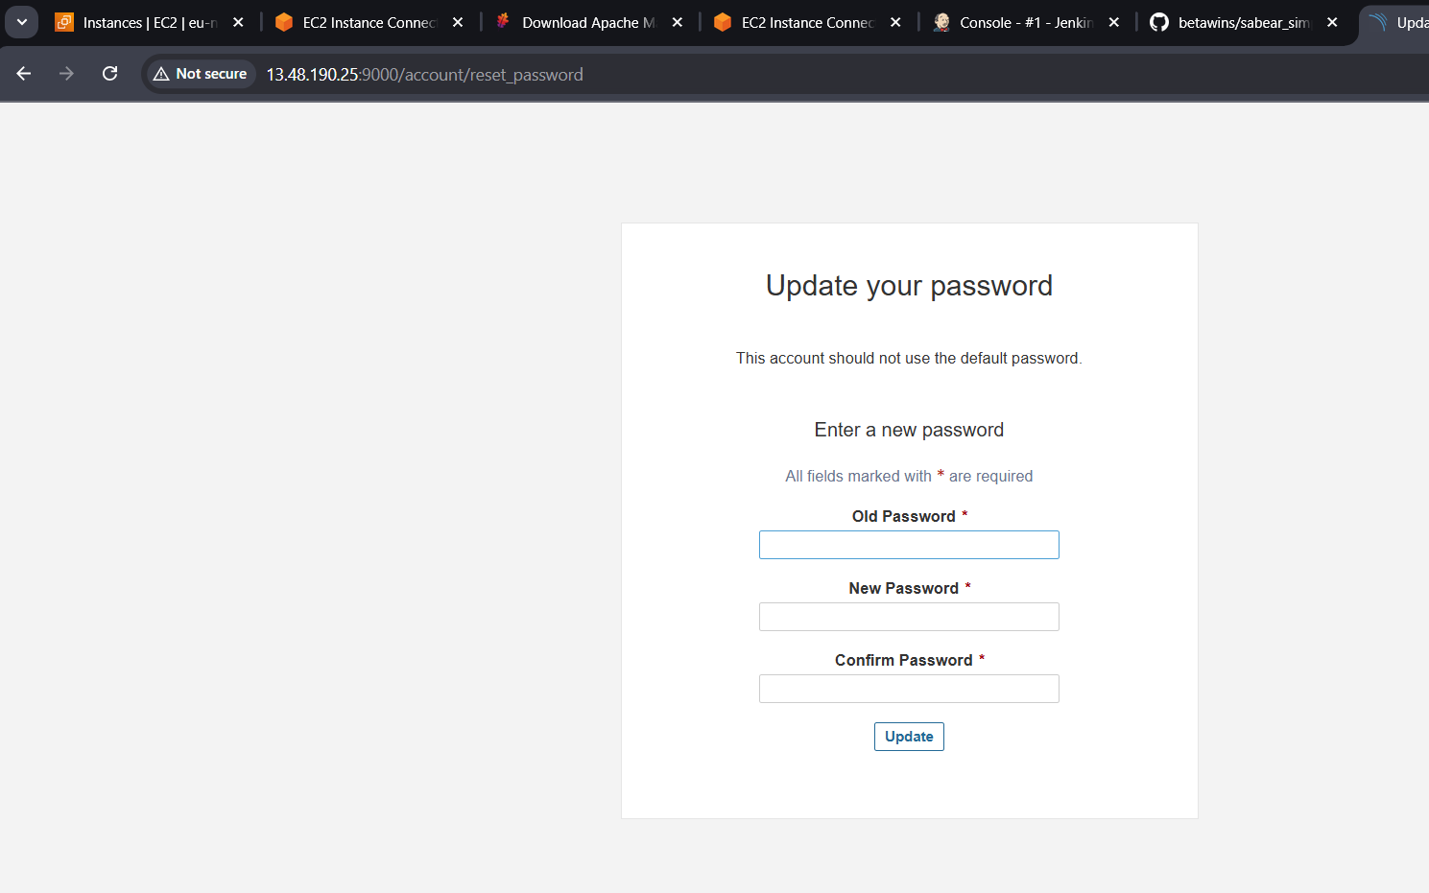
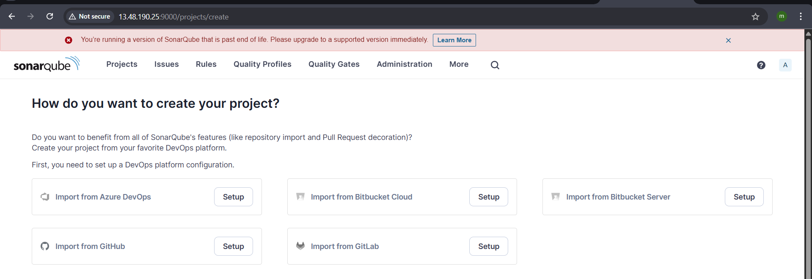
Now create token
goto myaccount generate tokencopy the secret text.
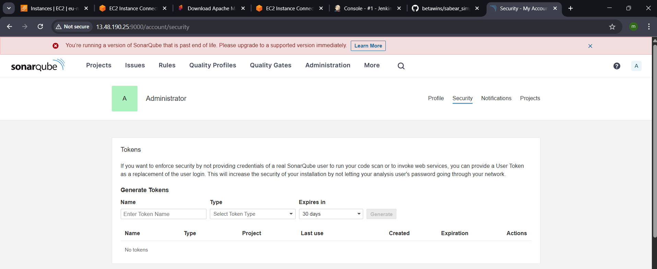
go to Jenkins—manage –system—sonarqube installation—add – secret text and url https://ipadress:9000– pate the text –save
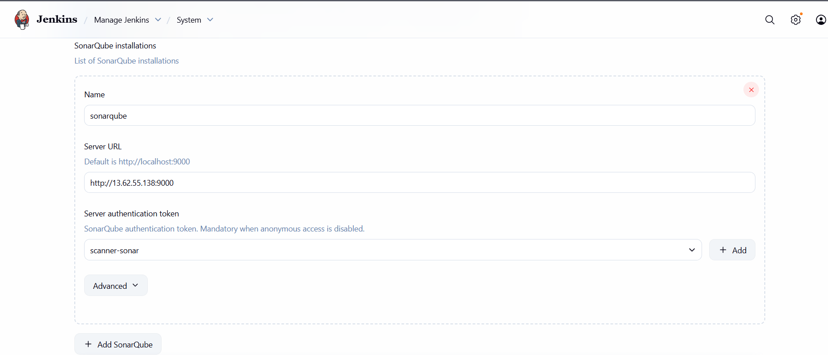
Now go to the Jenkins server
Cd /opt/
Install sonar scanner wget urlunzip fille.zip
Remane :mv sonar-scanner 6.0.0 sonar_scanner
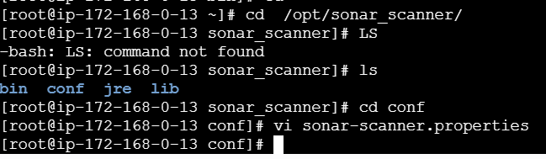
Go to cd /opt/sona_scanner/conf/
Vi sonar.properties
Add url = https:// ip sonarqube:port(9000) :wq!
Save and exit
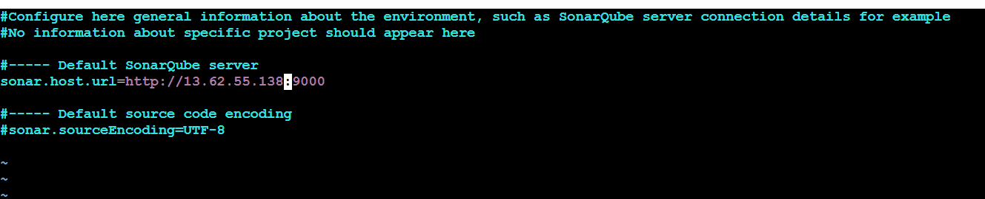
Build the job in the Jenkins
- Give the repo url add build stepsexecute sonar scanner

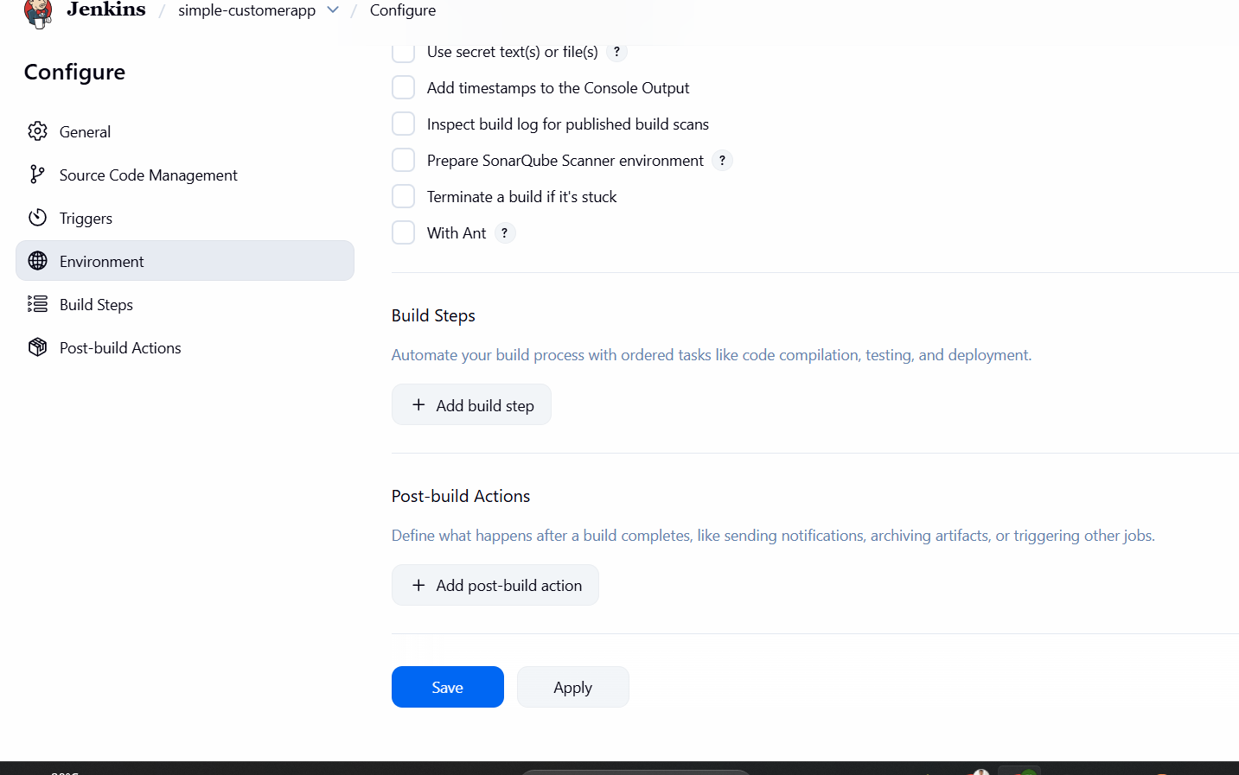
execute sonarqube sannergive analysis
sonar.projectKey=SimpleCustomerAppKey:SimpleCustomerApp
sonar.projectName=SimpleCustomerApp
sonar.projectVersion=2.0
sonar.sources = SimpleCustomerApp\\src
sonar.java.coveragePlugin=cobertura
sonar.core.codeCoveragePlugin=cobertura
sonar.junit.reportsPath=\\SimpleCustomerApp\\Reports\\BuildsUTCResults\\data
sonar.cobertura.reportPath=\\SimpleCustomerApp\\Reports\\BuildsCodeCoverage\\cobertura-xml\\coverage.xml
sonar.language=java
sonar.sourceEncoding=UTF-8
add one more build step invoke top level mavenmaven versiongoals clean install
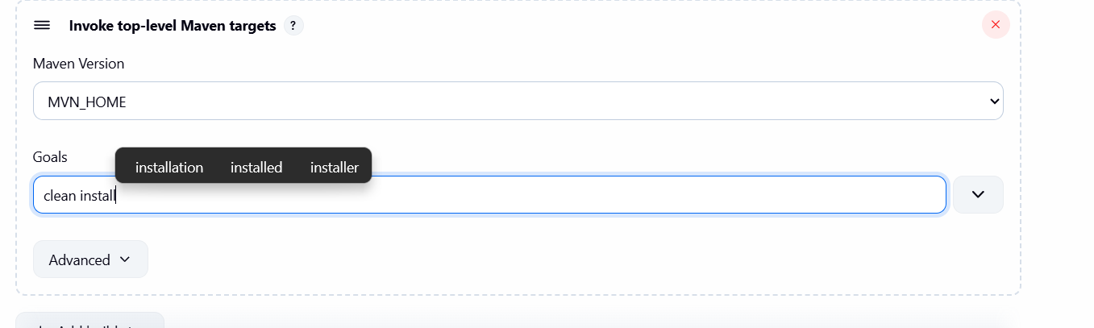
Save and build the job
Check the sonarqube
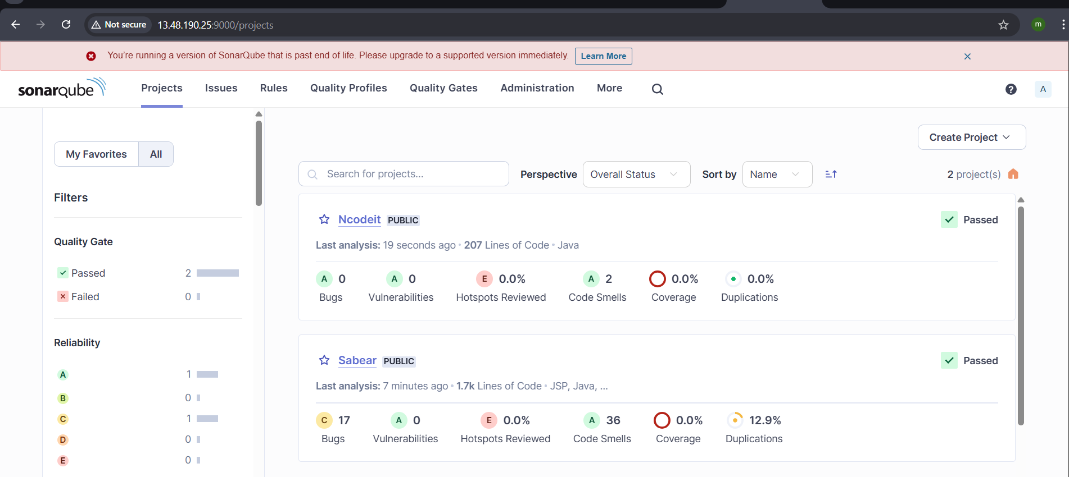

  - Maven Compilation
- Go to Jenkins server
- Cd /bin/ - change bin directory
- Go to browser : https://maven.apache.org/download.cgi
- Copy the download file link
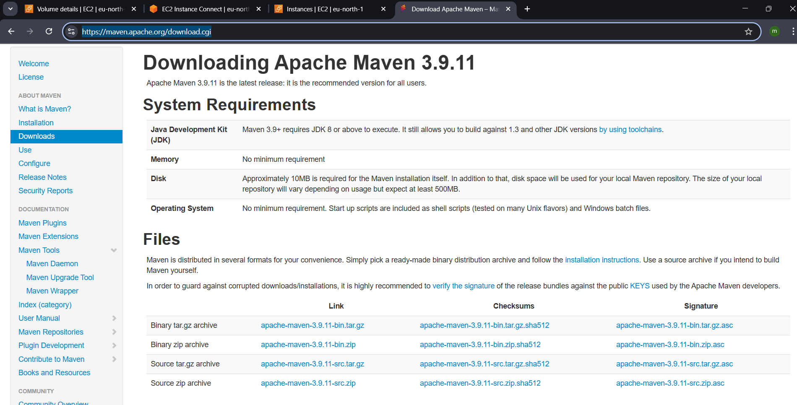
- now go to the Jenkins server
- login and got to bin directory : cd /bin/
- command to download the maven :
wget https://dlcdn.apache.org/maven/maven-3/3.9.11/binaries/apache-maven-3.9.11-bin.tar.gz

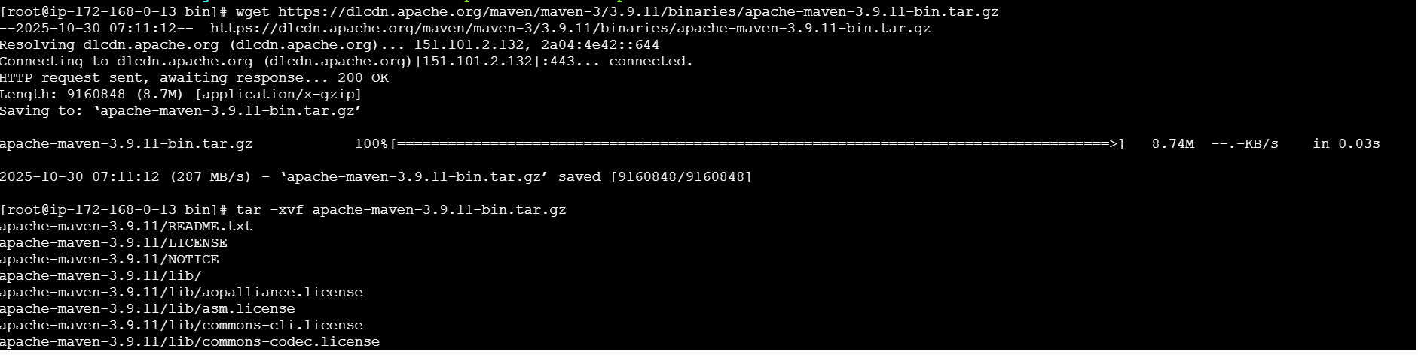
Extract : tar -xvf <file_name>

Cd apache-maven-3.9.11/bin/
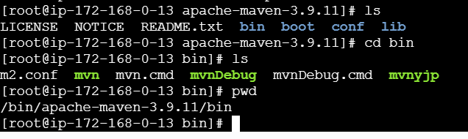
Pass the global variable to maven
Go to home directory

Vi .bash_profile # .bash_profile

# Get the aliases and functions
if [ -f ~/.bashrc ]; then
. ~/.bashrc
fi

# Set Maven environment
export MVN_HOME=/opt/apache-maven-3.9.11/bin
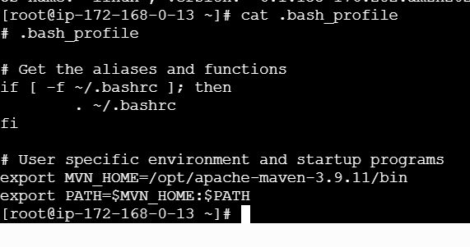
export PATH=$MVN_HOME:$PATH
- now go to Jenkins mangetoolsfind maven installations

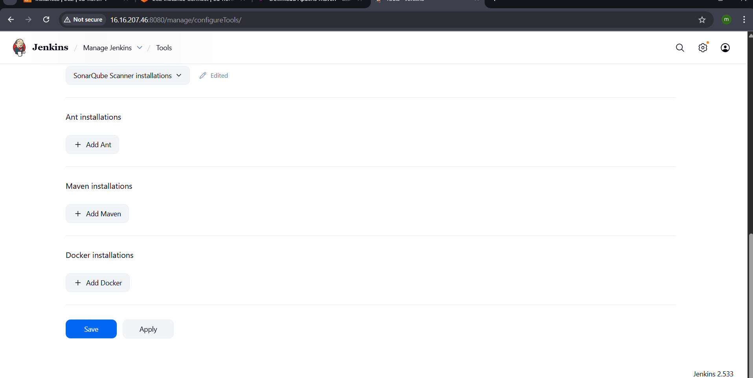
now run : source ~/.bash_profile
check :echo $MVN_HOME -shows the path
check :mvn –version
it shows the maven version
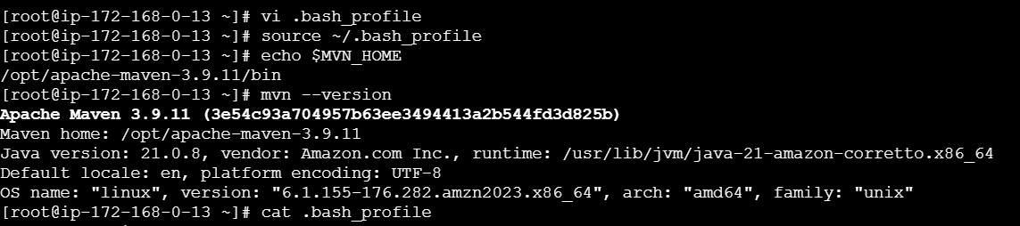
Go to Jenkins—job : simpleconfigure add build triggerinvoke mavenmavenversiongoals :clean installsave and build the job.
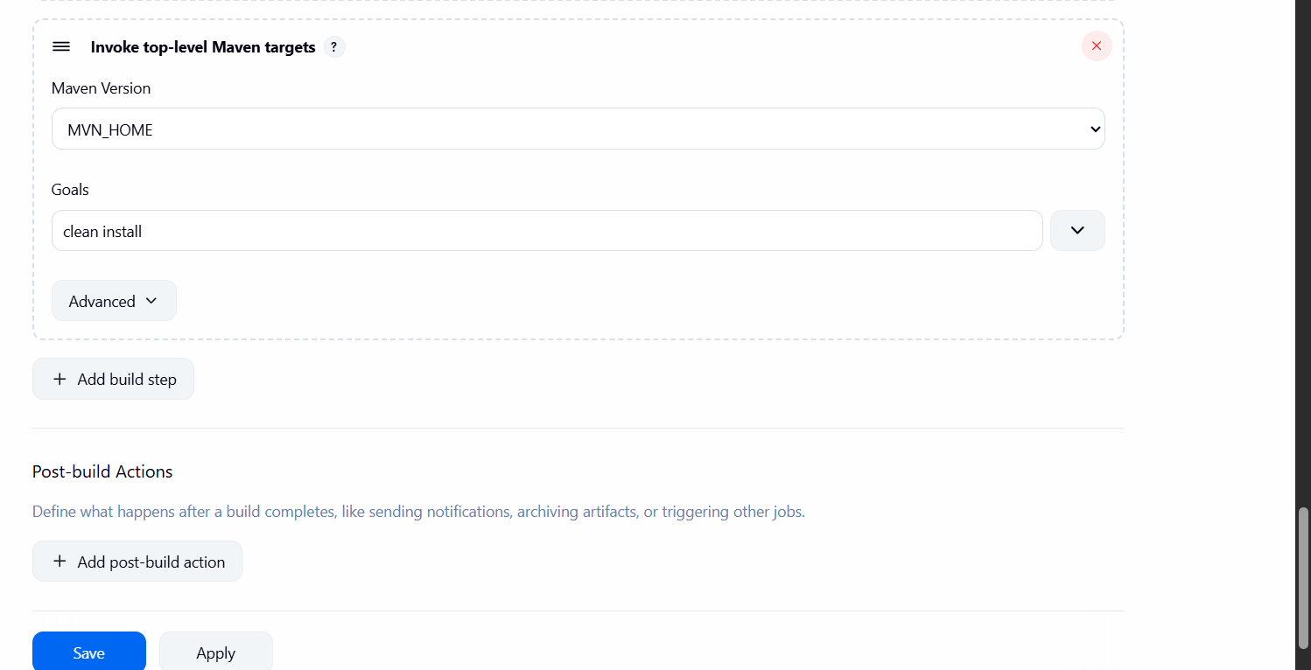
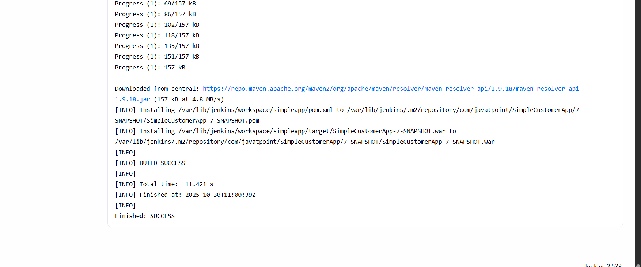
Job is completed successfully.
  - Nexus Artifactory
Lauch the instance for the nexus server
With t3.micro instance type
Nexus dependencies is only java
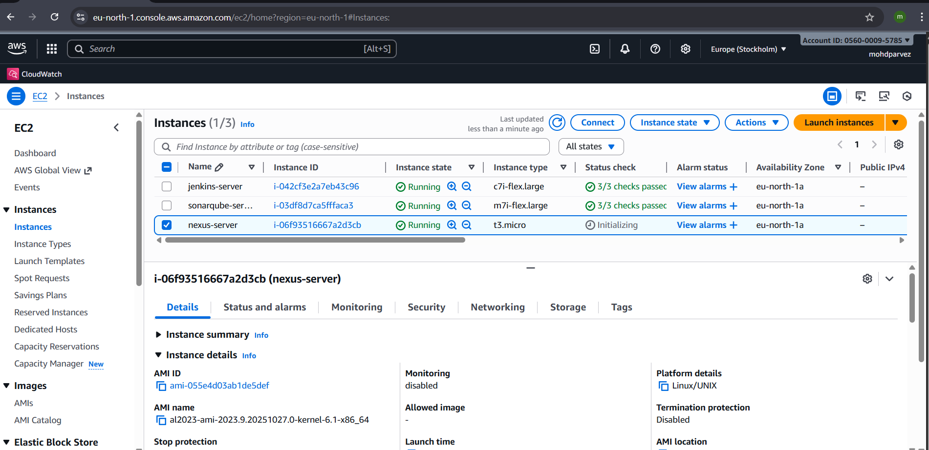
Connnect to the instance
Install java: yum install java-1.8*
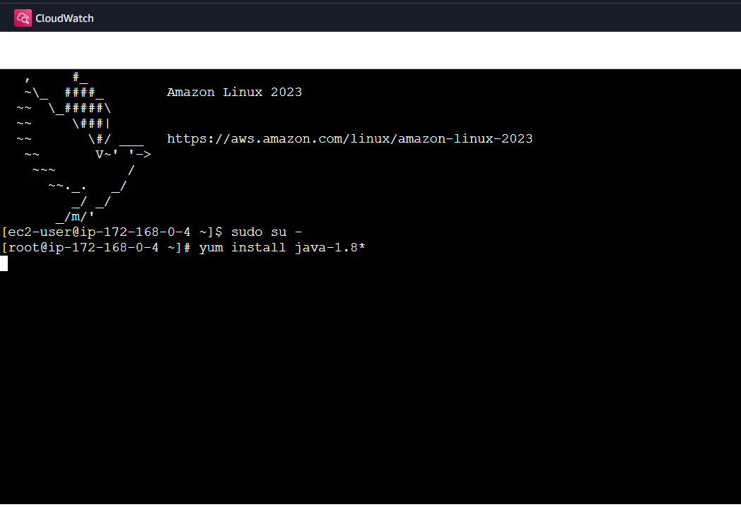
# Download Nexus
wget https://download.sonatype.com/nexus/3/nexus-3.77.2-02-unix.tar.gz

sudo tar -xvzf nexus-3.77.2-02-unix.tar.gz
mv /opt/ nexus-3.77.2-02 /opt/nexus
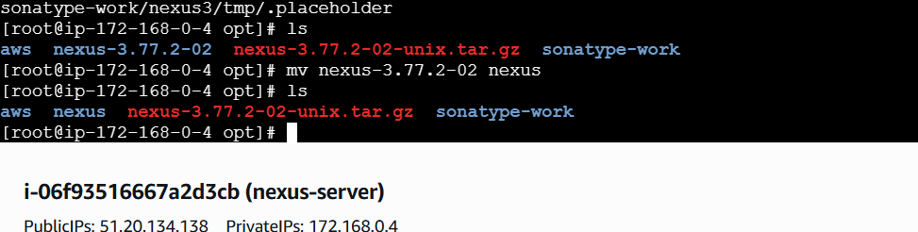
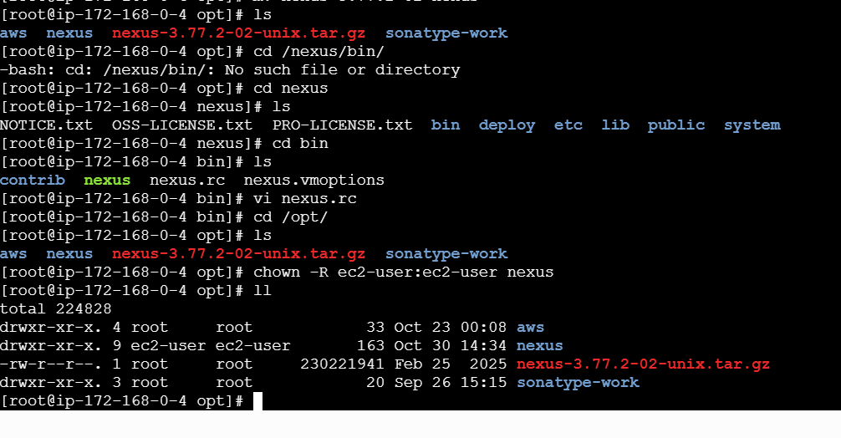
Cd /opt/nexus/bin/
Vi nexus.rc run_user_as=”nexus”:wq!
Chown -R nexus /opt/nexus

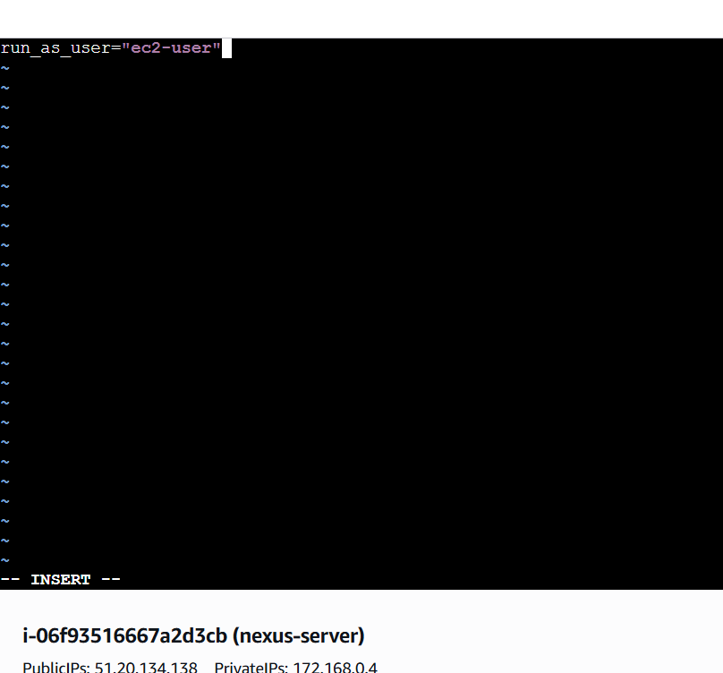
Cd /opt/nexus/bin/
./nexus start : START THE NEXUS
CHECK ON BROWSER WITH : <IPADRESS>:8081
ENABLE PORT IN SECURITY GROUPS :8081
sudo mkdir -p /opt/sonatype-work/nexus3/log
sudo chown -R nexus:nexus /opt/nexus /opt/sonatype-work
sudo chmod -R 755 /opt/nexus /opt/sonatype-work

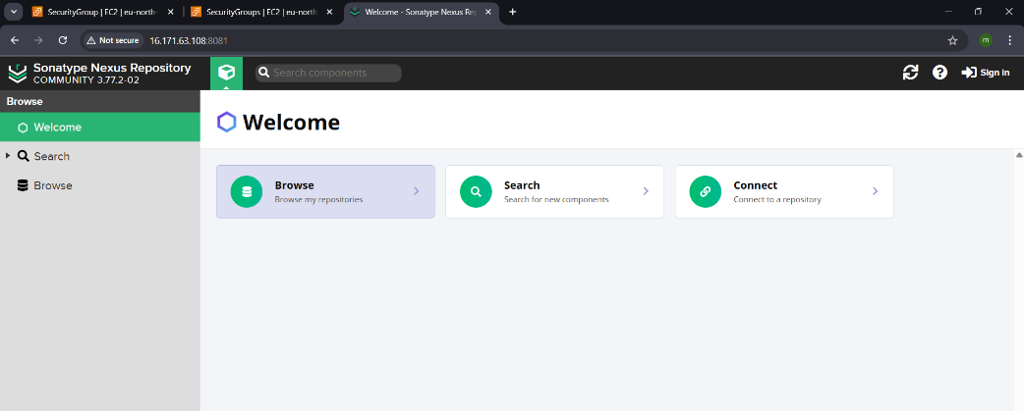
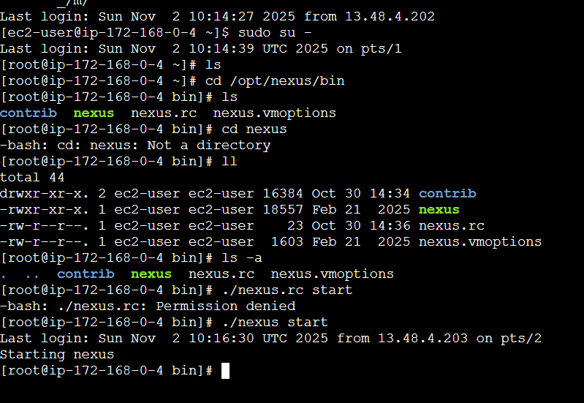
- Download nexus artifact uploader plugin
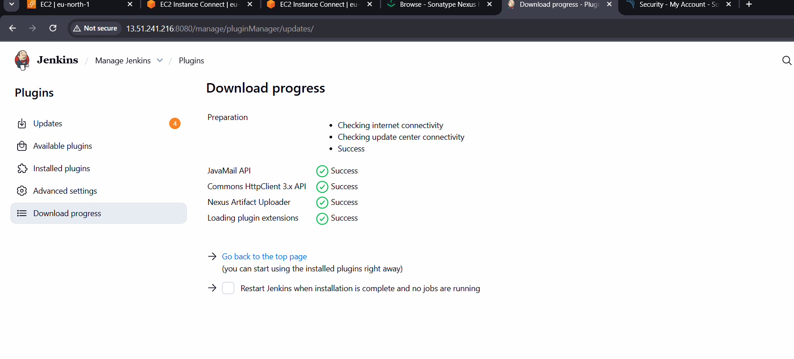
Go to nexussettingscreate repositoryselect maven 2hosted
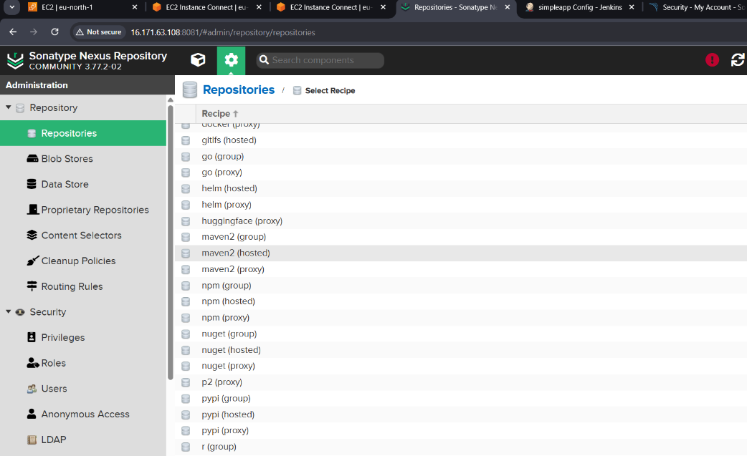
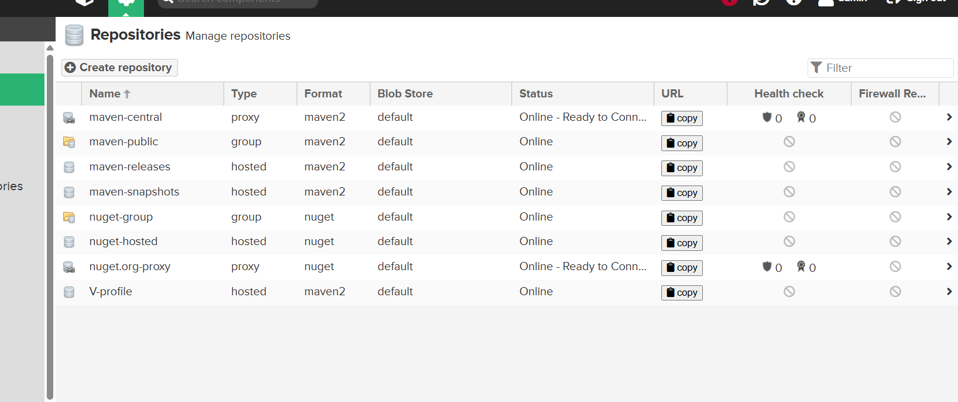
Build the job and check in the nexus server
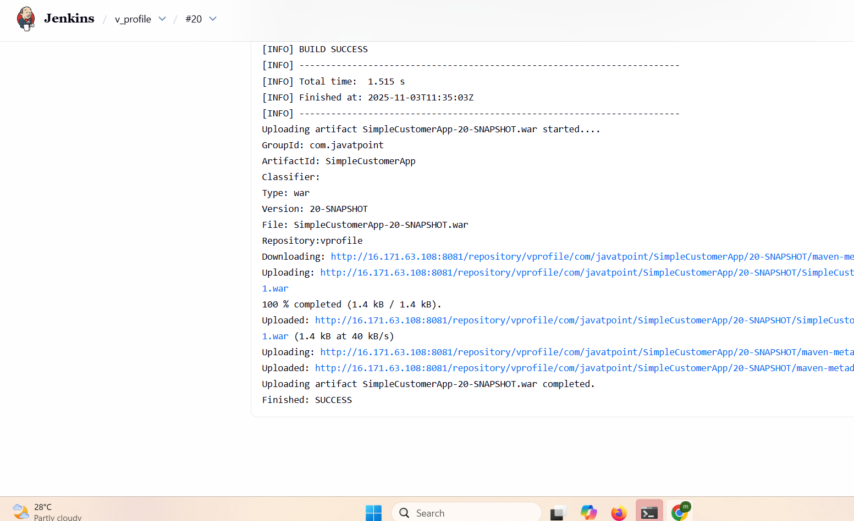

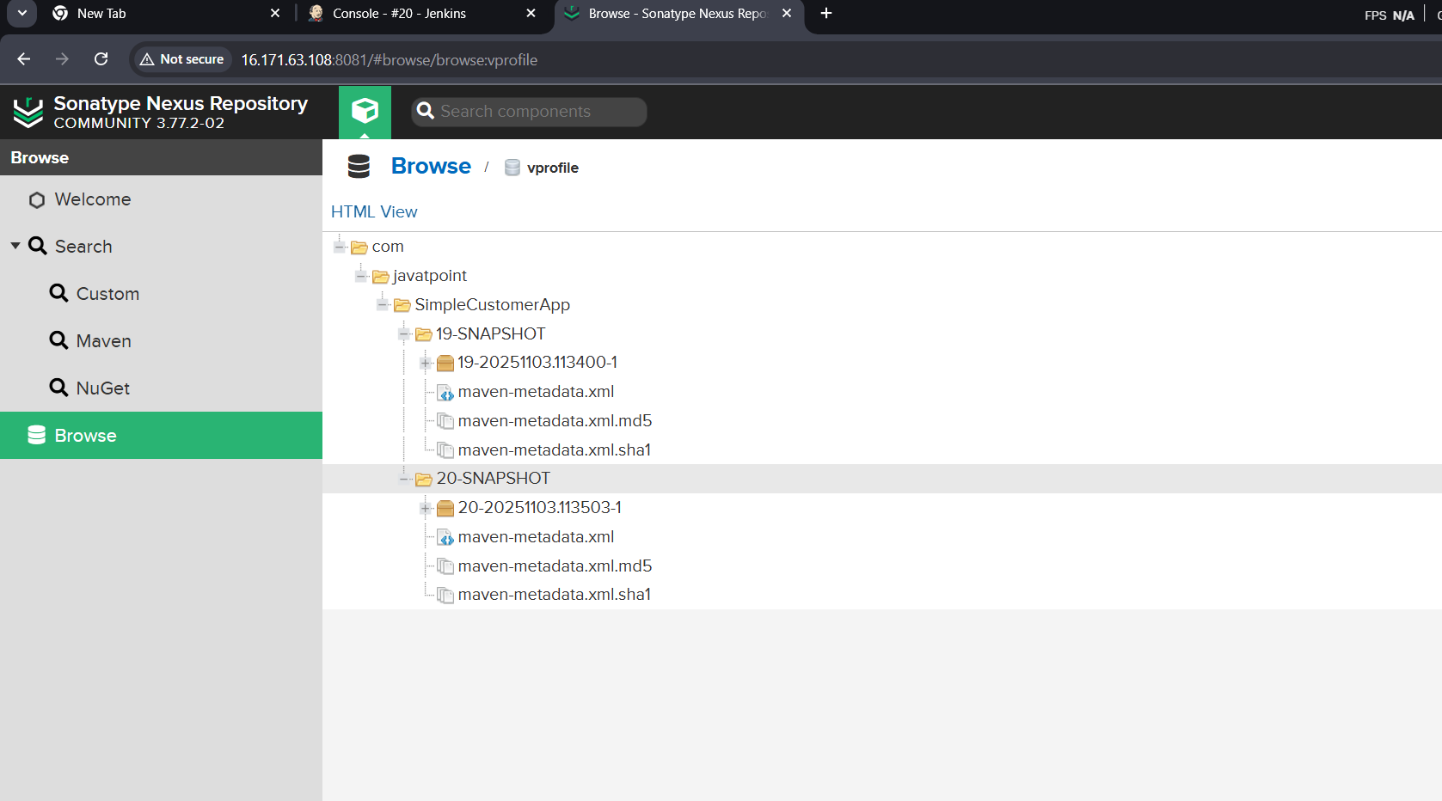

  - Slack Notification
Go to slackmoreappsjenkins Ciopen
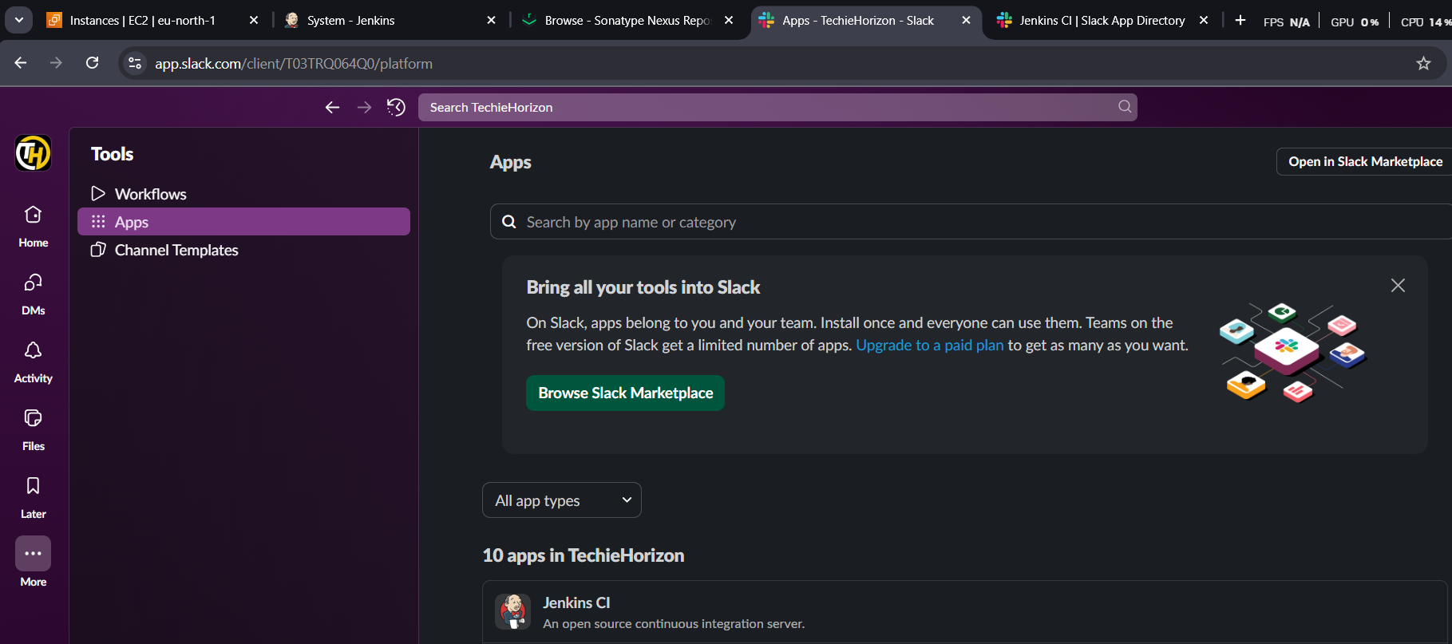
openconfigadd to slackselect channelfollow the steps addthe secret text and workspace as shown in jenkins
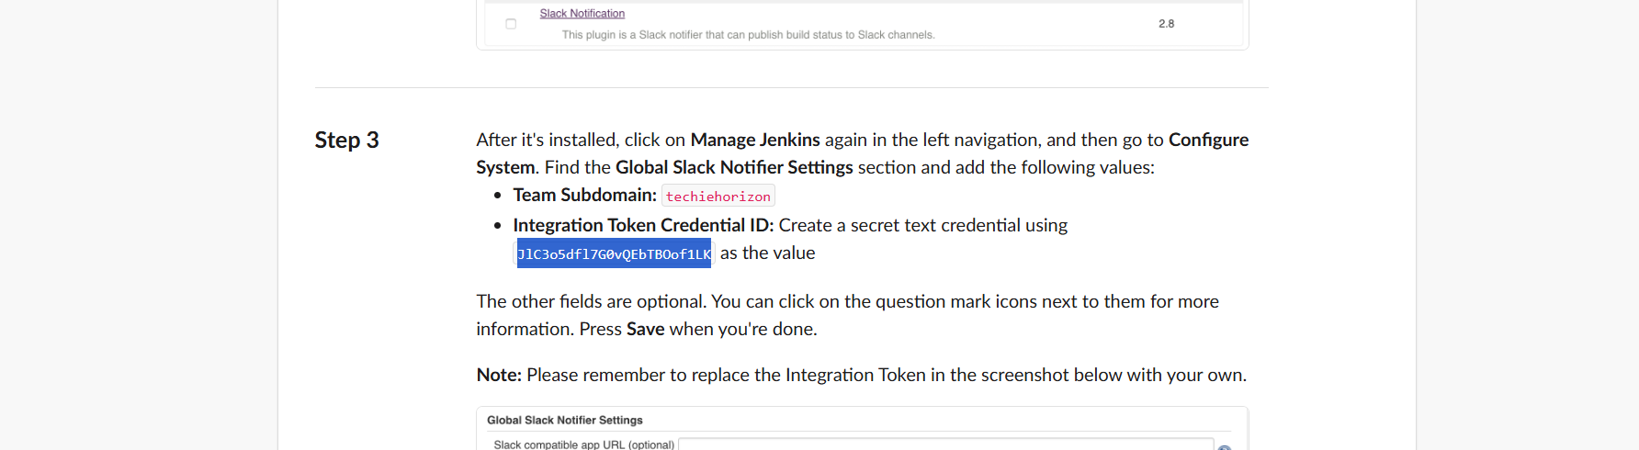
add to Jenkins and test connection
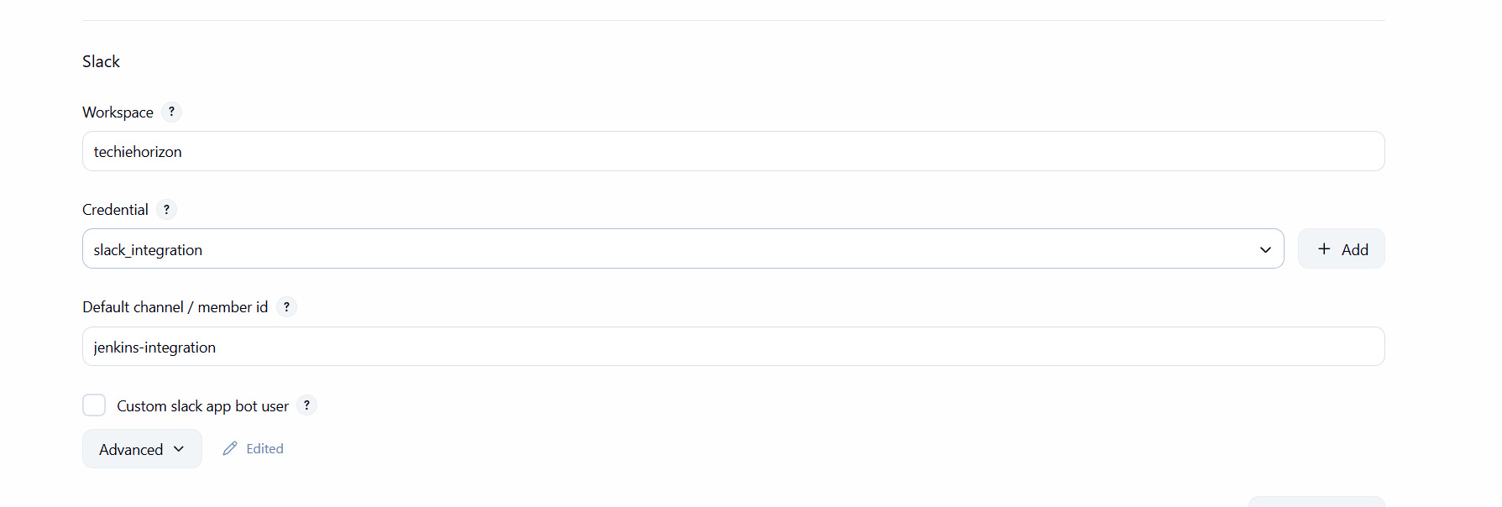
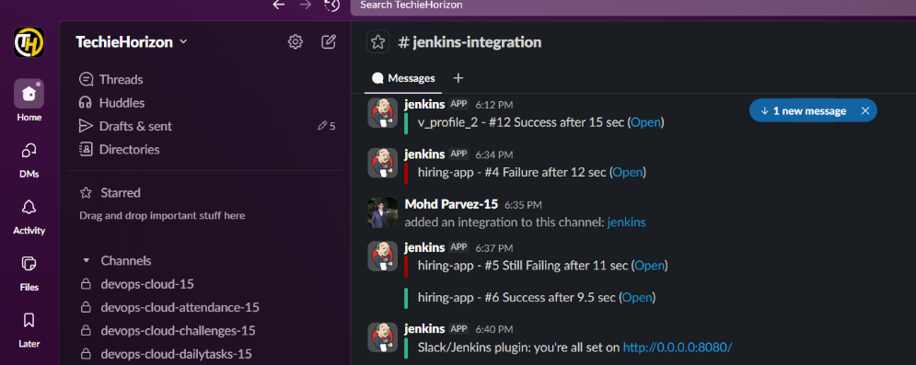
  - Deploy On tomcat
get the link to download on browser copy the link
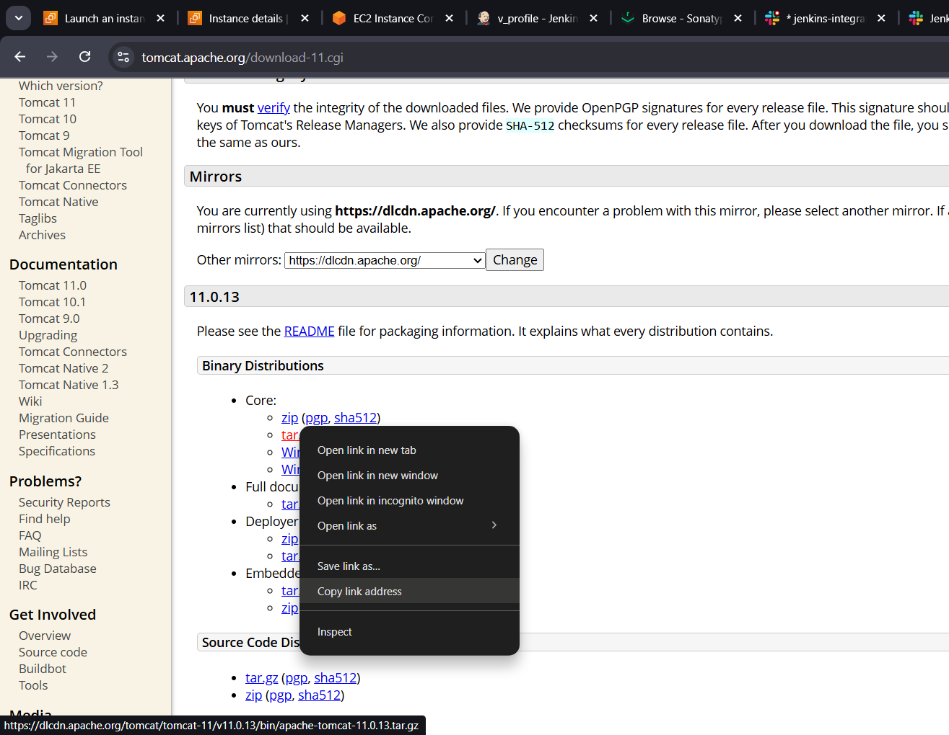
Launch instance for tomcat server t3.micro
Install java : yum install java-17
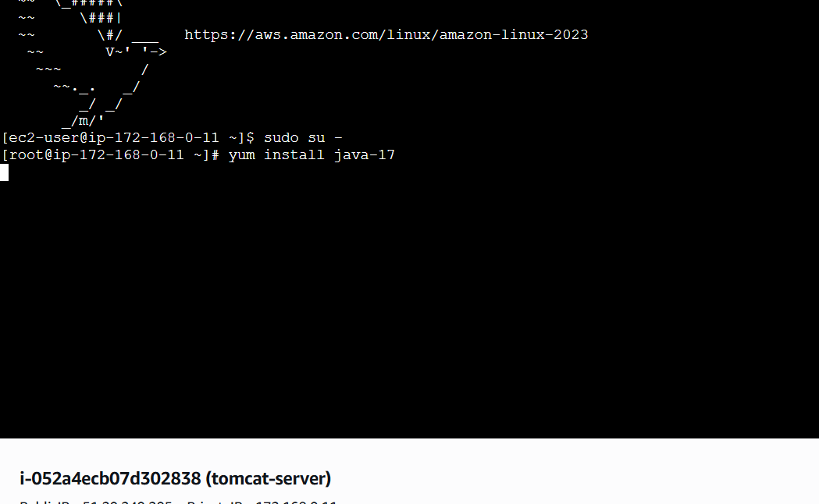
Download tomcat
Wget https://dlcdn.apache.org/tomcat/tomcat-9/v9.0.111/bin/apache-tomcat-9.0.111.tar.gz
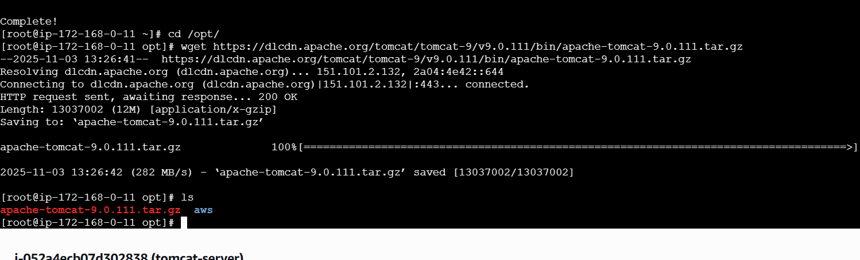
Exract the downloaded file : tar xvf “filename”
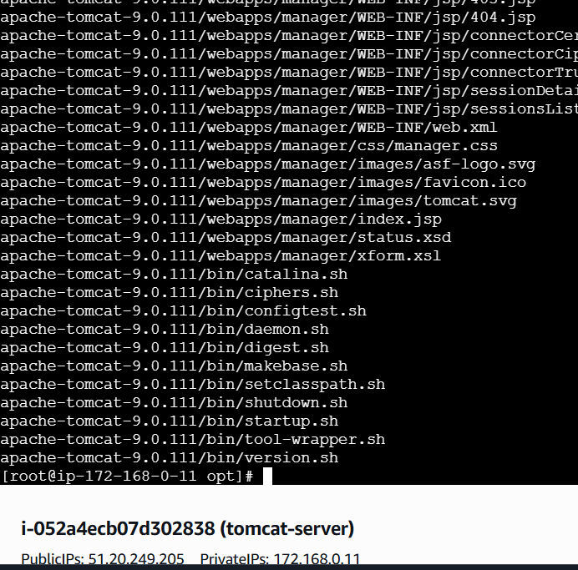
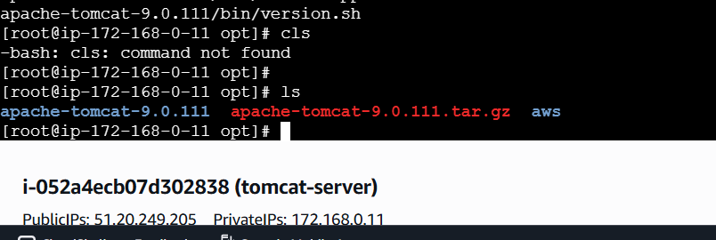
Go to bin directory
Cd /opt/tomcat_09/bin/
./startup.sh : to start the tomcat

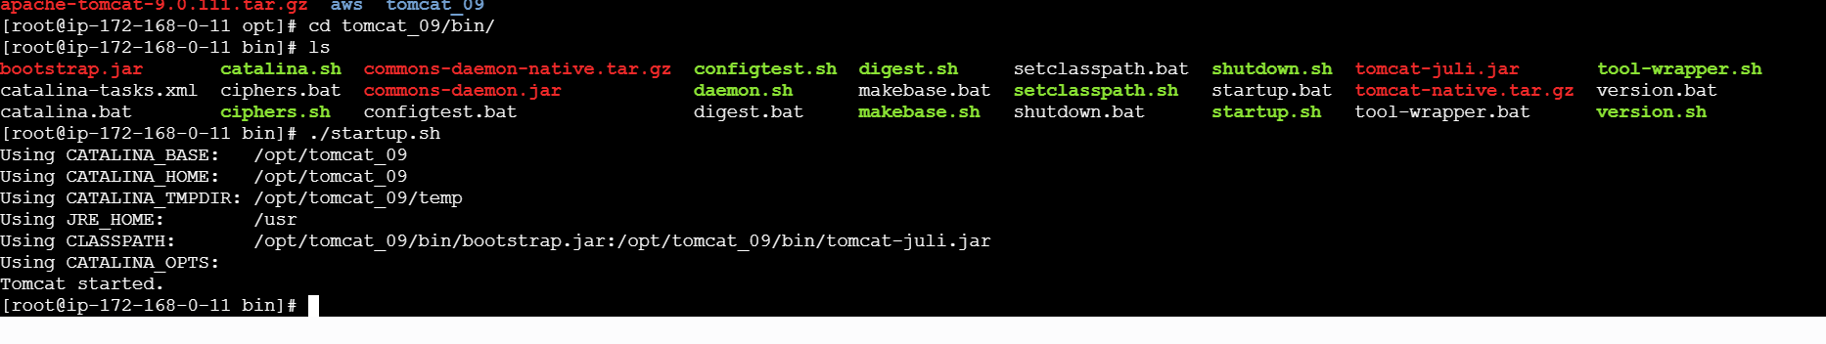
Check on the browser: <ipadress>:8080
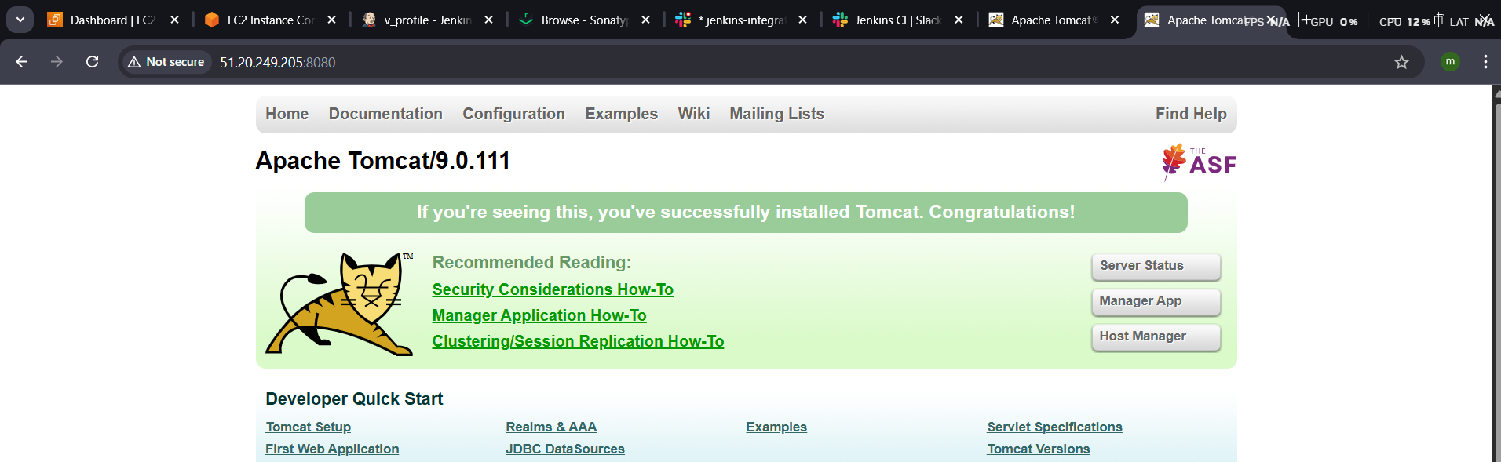
Install plug in in Jenkins : deploy to container plugin
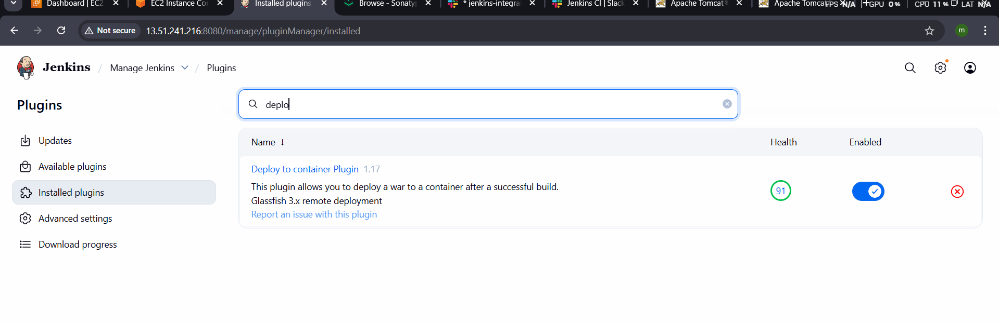

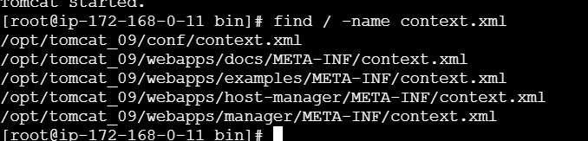
Then open the file and edit with the vi add <!-- & -->
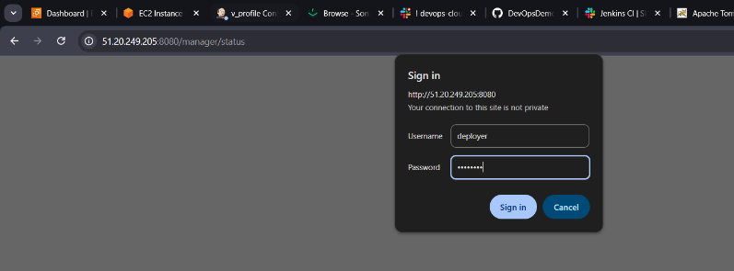
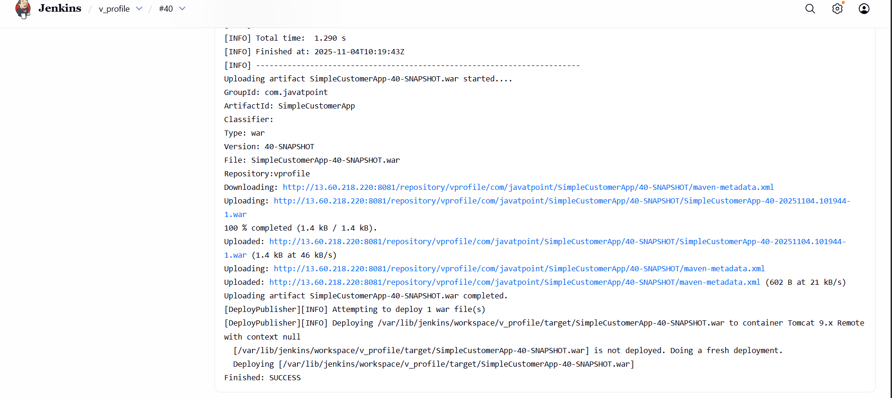

- Setup a Jenkins CICD pipeline using Declarative pipeline using feature-1.1 branch. https://github.com/betawins/sabear_simplecutomerapp/tree/feature-1.1
stages:
  - Git Clone
pipeline {
agent any
stages {
stage('Git Clone') {
steps {
git 'https://github.com/betawins/sabear_simplecutomerapp.git'
}
}
}
}
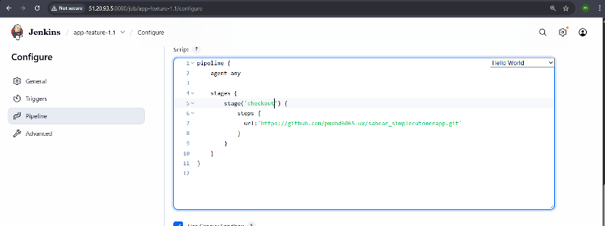
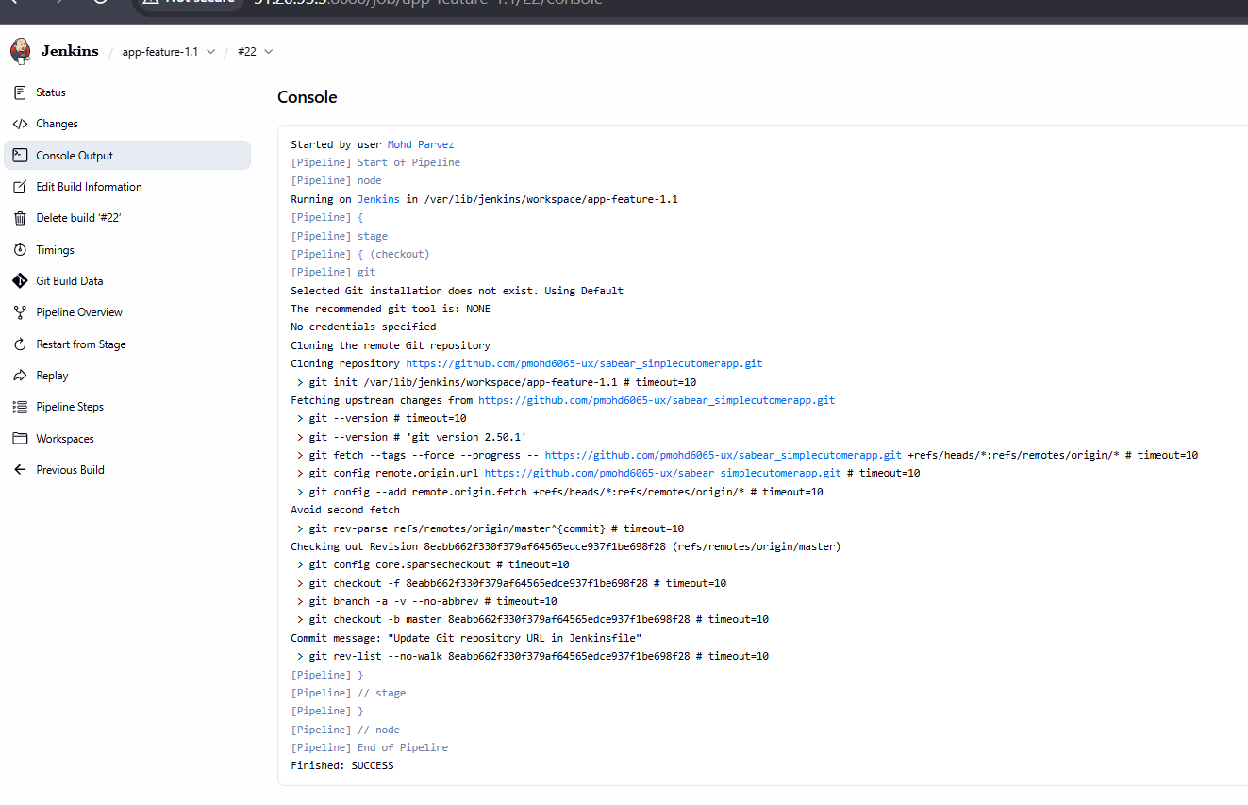
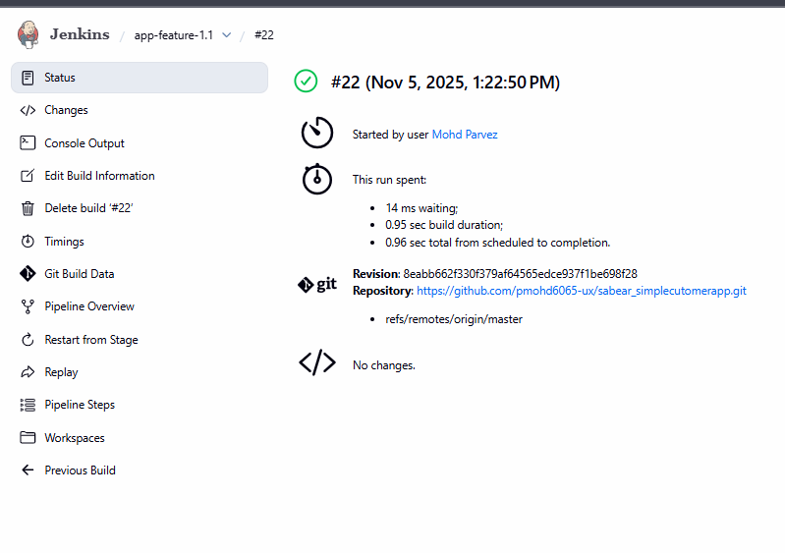

  - Maven Compilation
pipeline {
agent any

tools {
maven "MVN_HOME"
}

stages {
stage('Checkout') {
steps {
git branch: 'master',
url: 'https://github.com/pmohd6065-ux/sabear_simplecutomerapp.git'
}
}

stage('Build') {
steps {
sh 'mvn clean install -f pom.xml'
}
}
}

post {
success {
echo 'Build completed successfully!'
}
failure {
echo 'Build failed — check logs above.'
}
}
}
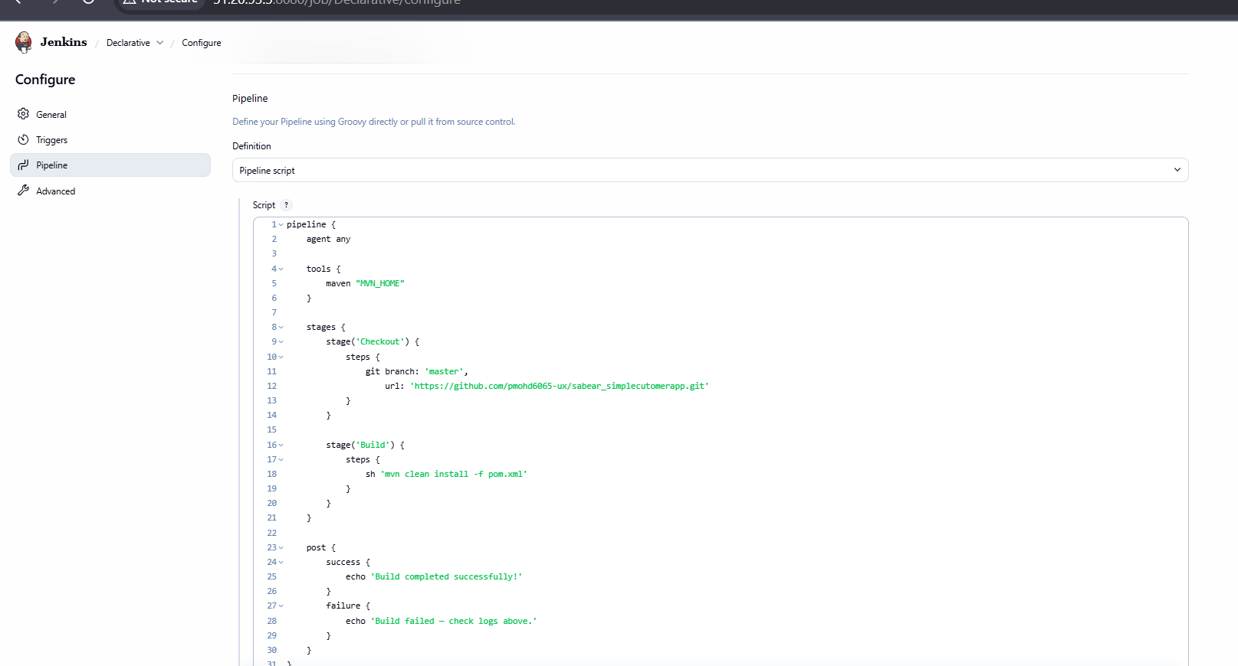

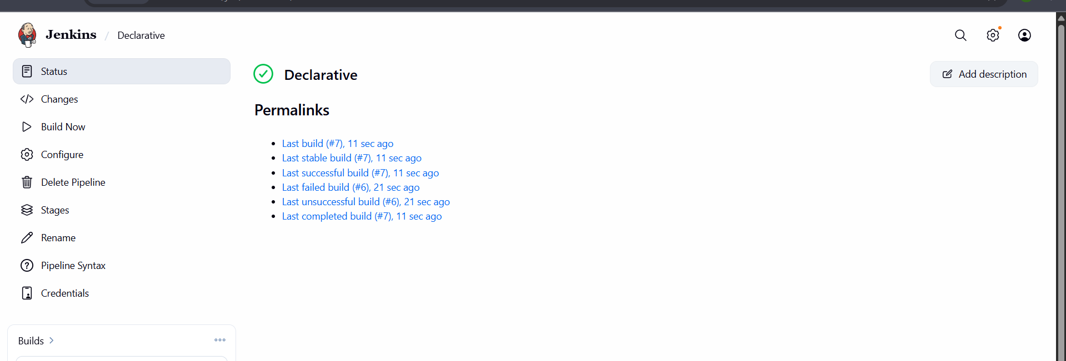

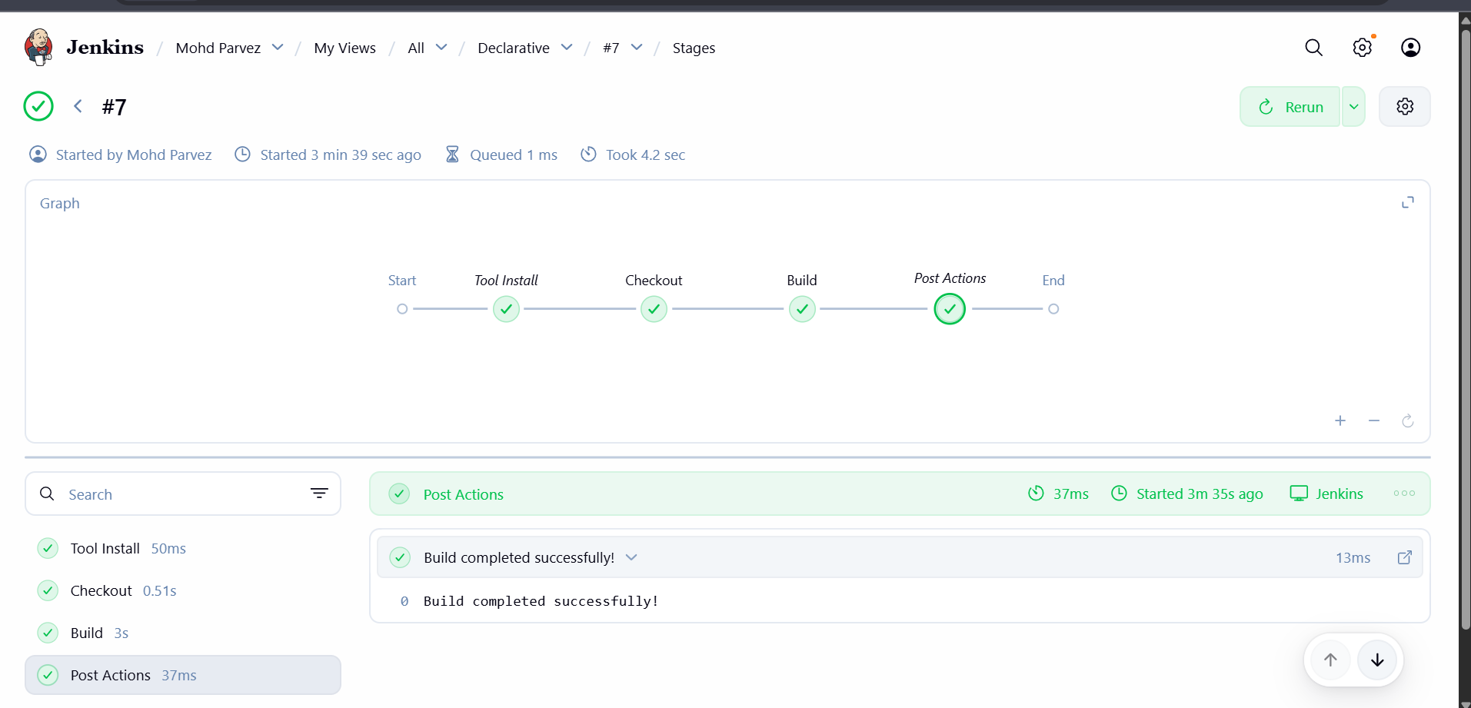

  - SonarQube Integration
pipeline {
agent any

tools {
maven "MVN_HOME"
}

stages {
stage('Checkout') {
steps {
git branch: 'master',
url: 'https://github.com/pmohd6065-ux/sabear_simplecutomerapp.git'
}
}

stage('Build') {
steps {
sh 'mvn clean install -f pom.xml'
}
}

stage('SonarQube Analysis') {
steps {
// Run SonarQube analysis using the configured installation and credentials
withSonarQubeEnv(installationName: 'SonarQube', credentialsId: 'feature1.1') {
sh 'mvn sonar:sonar'
}
}
}
}

post {
success {
echo 'Pipeline completed successfully!'
}
failure {
echo 'Pipeline failed. Check logs for details.'
}
}
}
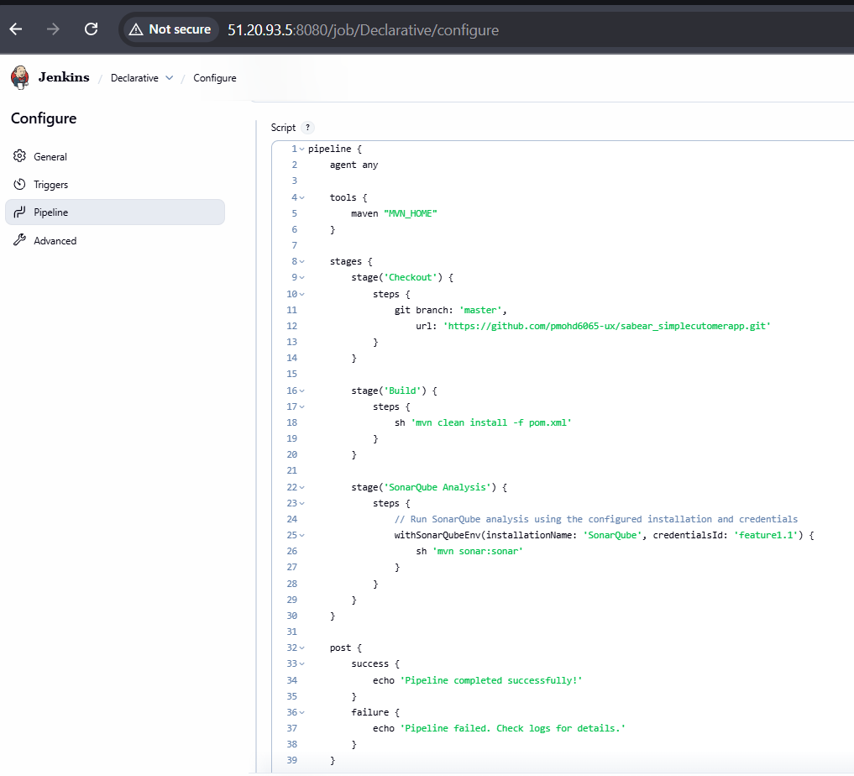
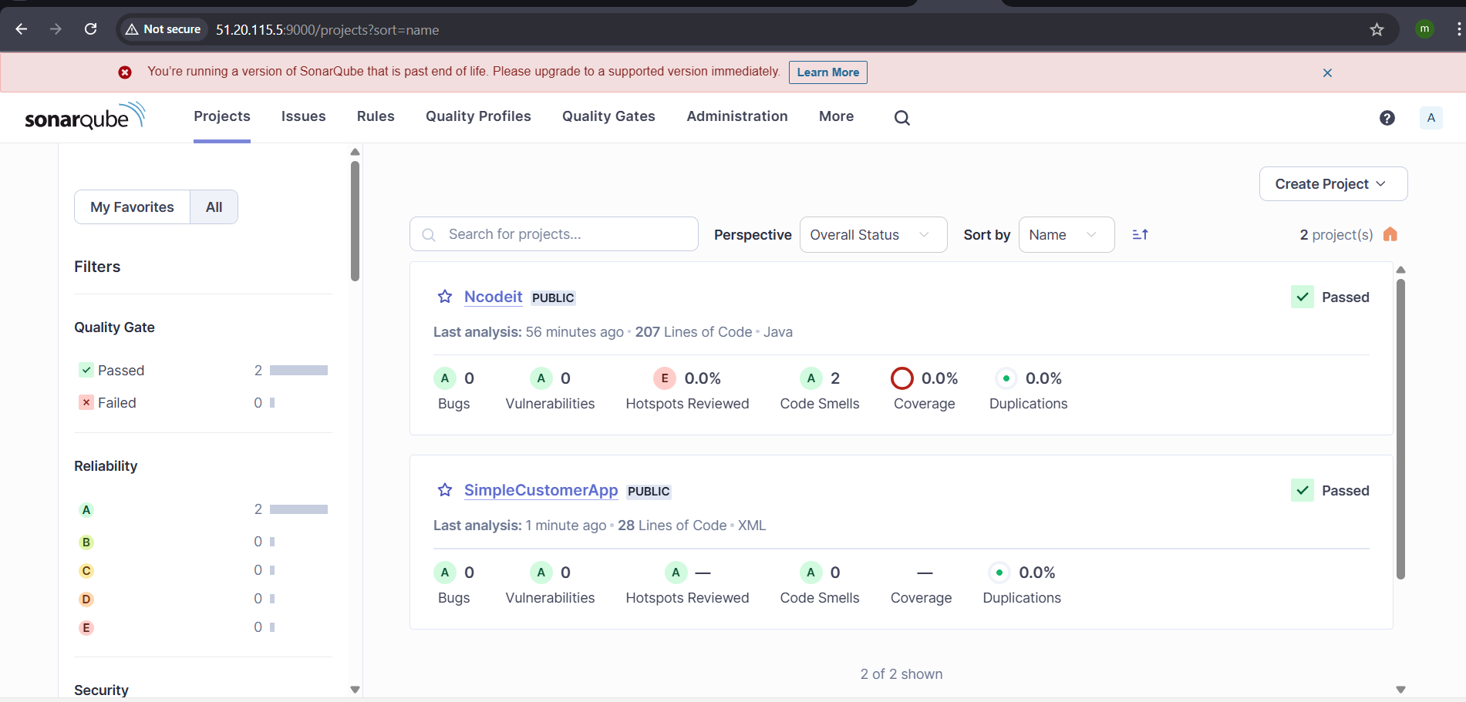
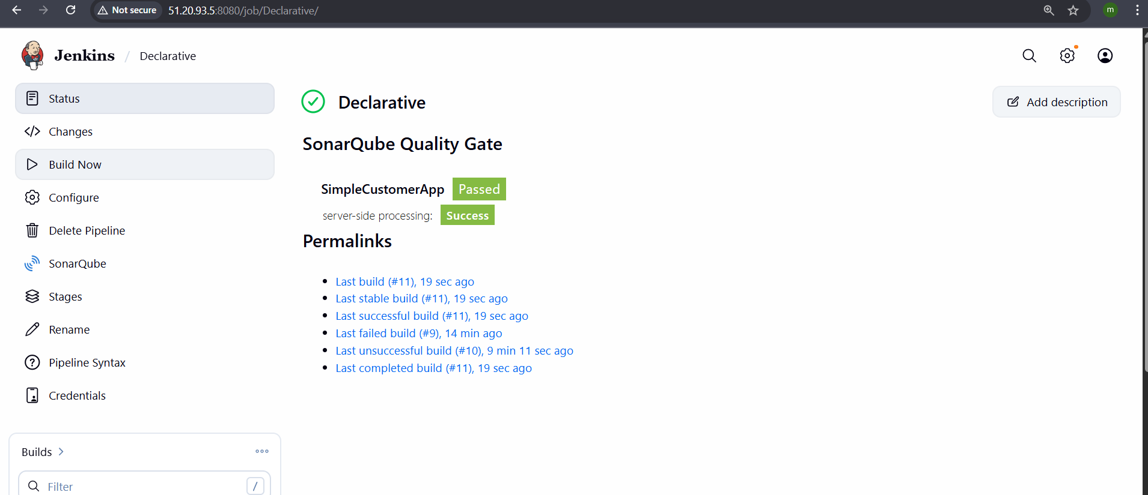
  - Nexus Artifactory
pipeline {
agent any

tools {
maven "MVN_HOME"
}

stages {
stage('Checkout') {
steps {
git branch: 'master',
url: 'https://github.com/pmohd6065-ux/sabear_simplecutomerapp.git'
}
}

stage('Build') {
steps {
sh 'mvn clean install -f pom.xml'
}
}

stage('SonarQube Analysis') {
steps {
withSonarQubeEnv(installationName: 'SonarQube', credentialsId: 'task-04') {
sh 'mvn sonar:sonar'
}
}
}

stage('Upload to Nexus') {
steps {
script {
nexusArtifactUploader(
artifacts: [[
artifactId: 'SimpleCustomerApp',
classifier: '',
file: "/var/lib/jenkins/workspace/Declarative/target/SimpleCustomerApp-${BUILD_NUMBER}-SNAPSHOT.war",
type: 'war'
]],
credentialsId: 'nexus',
groupId: 'com.javatpoint',
nexusUrl: '13.49.224.44:8081',
nexusVersion: 'nexus3',
protocol: 'http',
repository: 'feature',
version: "${BUILD_NUMBER}-SNAPSHOT"
)
}
}
}
}

post {
success {
echo 'Pipeline completed successfully! Artifact uploaded to Nexus.'
}
failure {
echo 'Pipeline failed. Check logs for details.'
}
}
}

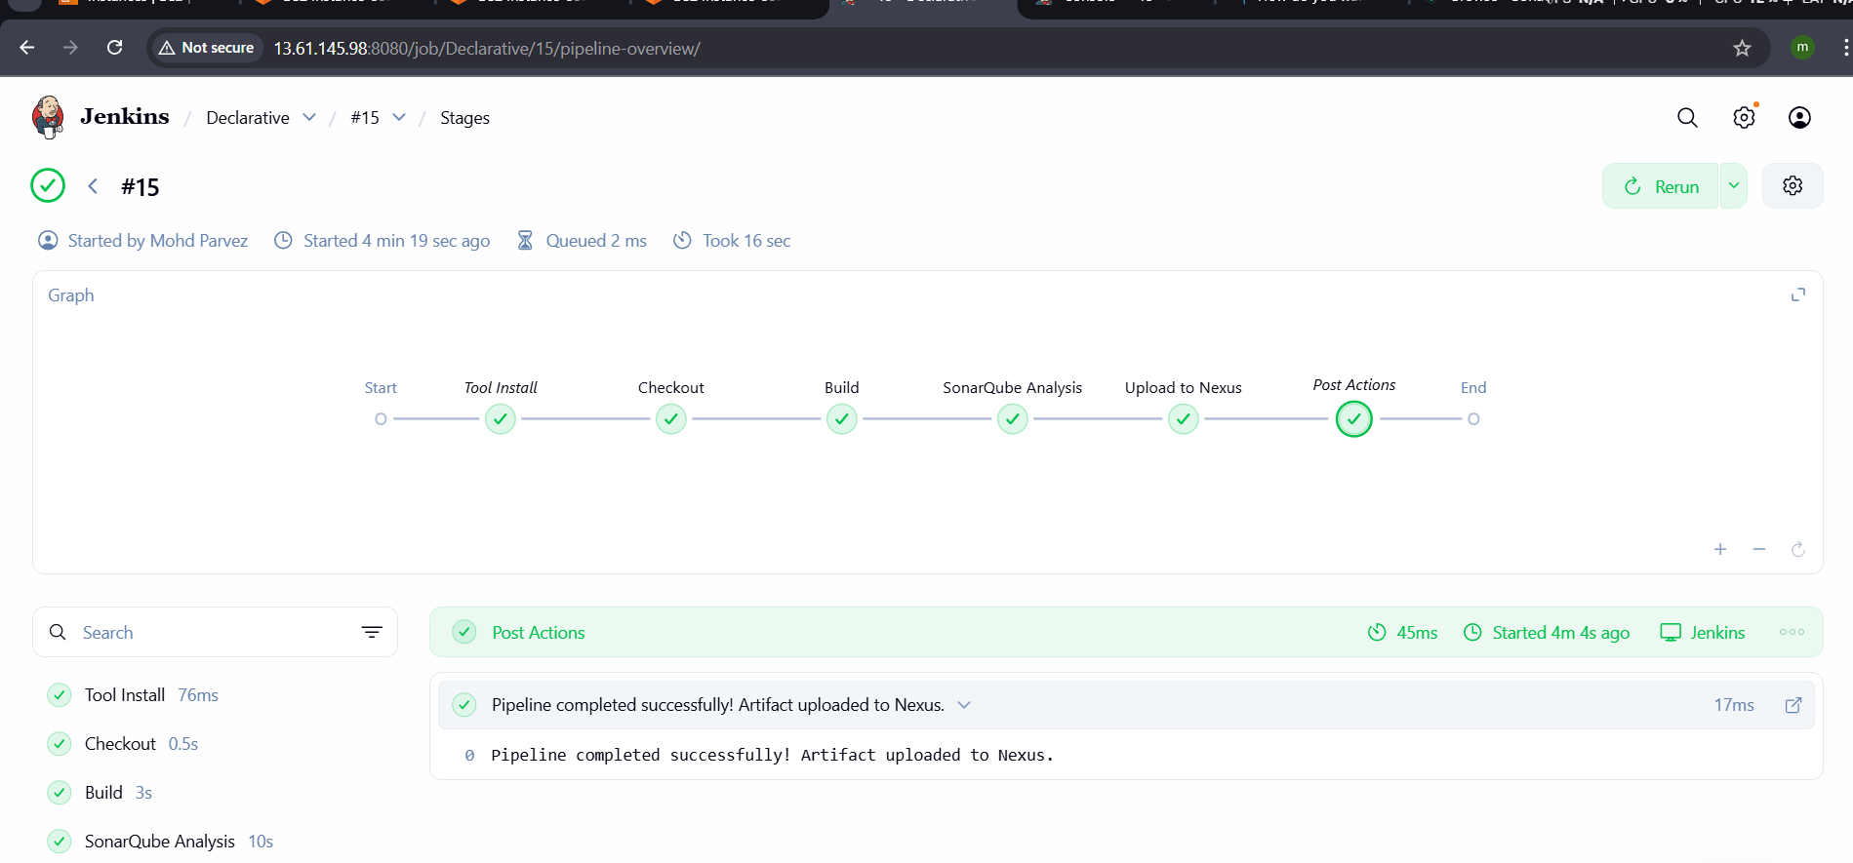
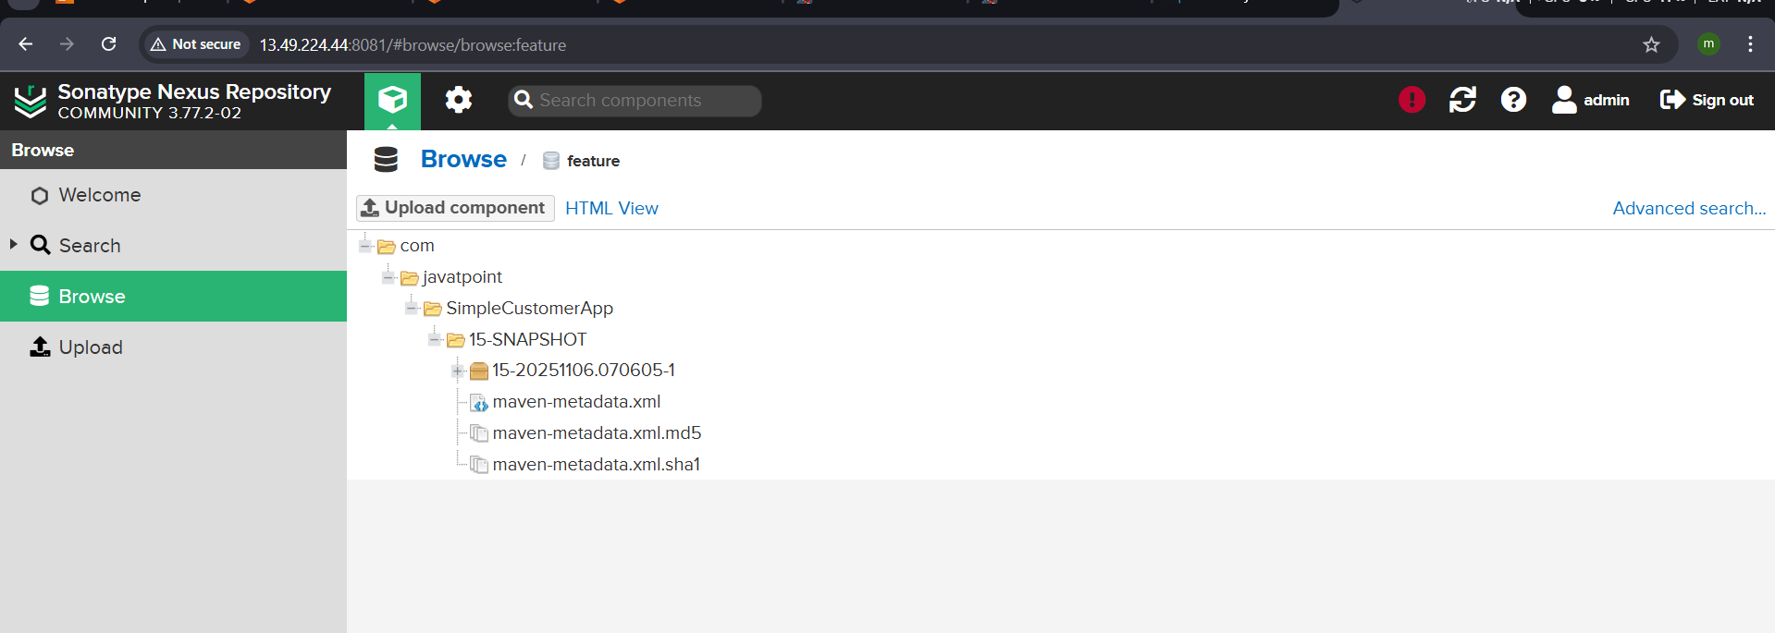

  - Deploy On tomcat
pipeline {
agent any

tools {
maven "MVN_HOME"
}

stages {
stage('Checkout') {
steps {
git branch: 'master',
url: 'https://github.com/pmohd6065-ux/sabear_simplecutomerapp.git'
}
}

stage('Build') {
steps {
sh 'mvn clean install -f pom.xml'
}
}

stage('SonarQube Analysis') {
steps {
withSonarQubeEnv('SonarQube') {
sh 'mvn sonar:sonar'
}
}
}

stage('Upload to Nexus') {
steps {
script {
nexusArtifactUploader(
artifacts: [[
artifactId: 'SimpleCustomerApp',
classifier: '',
file: "target/SimpleCustomerApp-${BUILD_NUMBER}-SNAPSHOT.war",
type: 'war'
]],
credentialsId: 'nexus',
groupId: 'com.javatpoint',
nexusUrl: '13.49.224.44:8081',
nexusVersion: 'nexus3',
protocol: 'http',
repository: 'feature',
version: "${BUILD_NUMBER}-SNAPSHOT"
)
}
}
}

stage('Deploy to Tomcat') {
steps {
script {
// Deploy WAR to Tomcat Manager using the deploy plugin
deploy adapters: [
tomcat9(
credentialsId: 'tomcat',
path: '',
url: 'http://13.51.233.27:8080/manager/text' // ✅ use the manager/text endpoint
)
],
contextPath: '/SimpleCustomerApp', // optional, define your app context
war: 'target/SimpleCustomerApp-*.war'
}
}
}
}

post {
success {
echo '✅ Pipeline completed successfully! Artifact uploaded to Nexus and deployed to Tomcat.'
}
failure {
echo '❌ Pipeline failed. Check logs for details.'
}
}
}

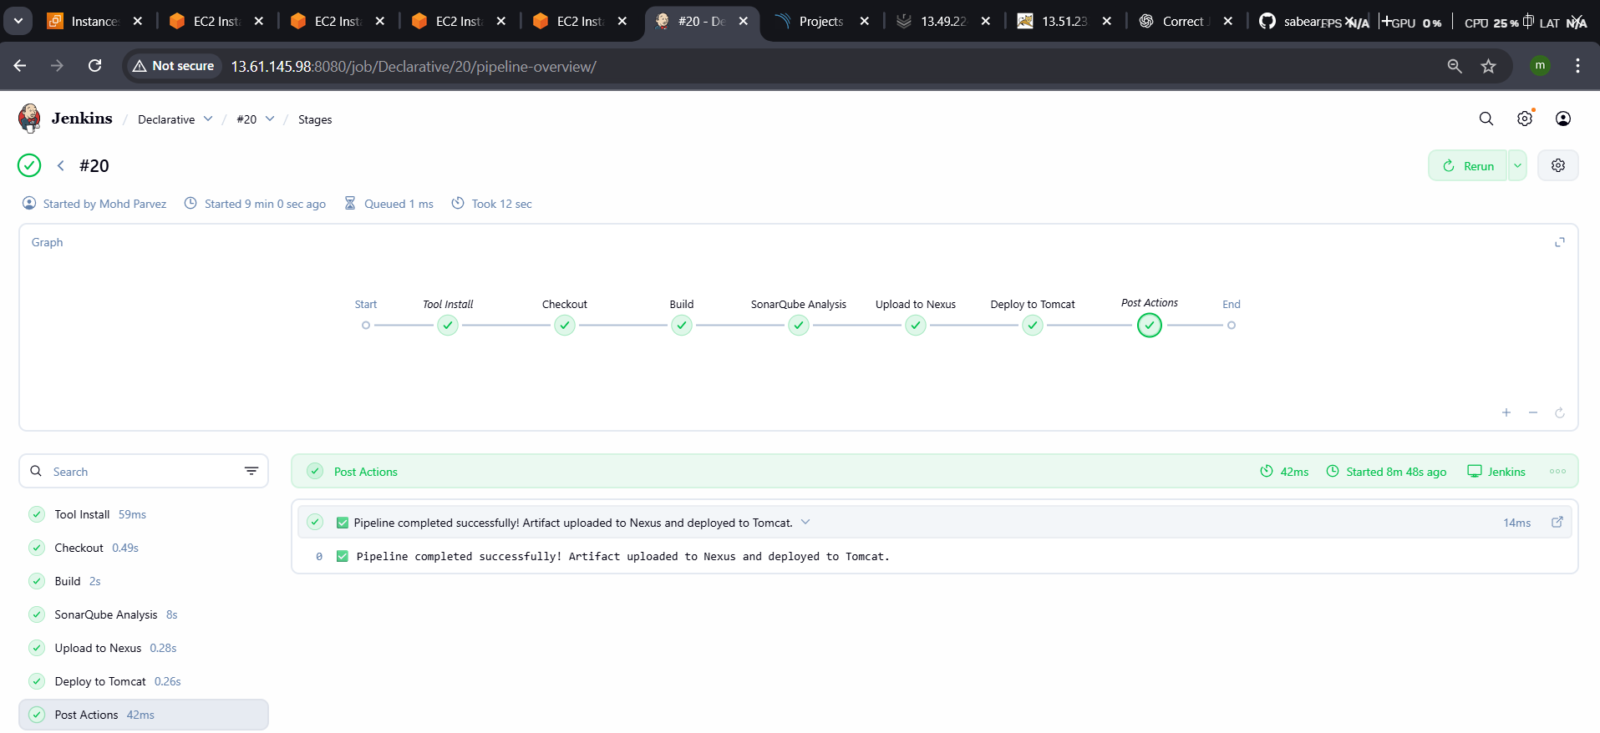

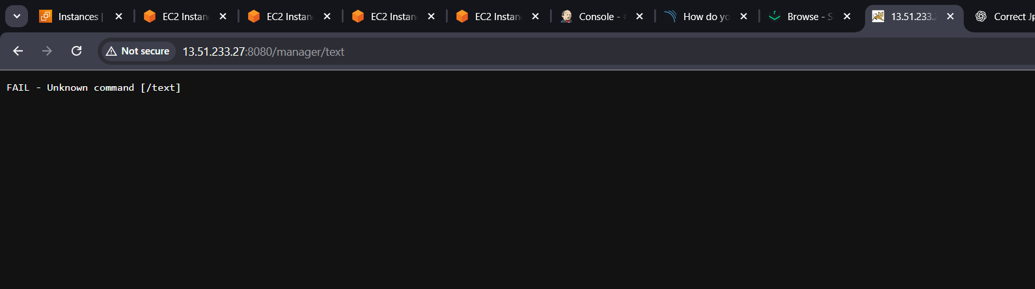
  - Slack Notification
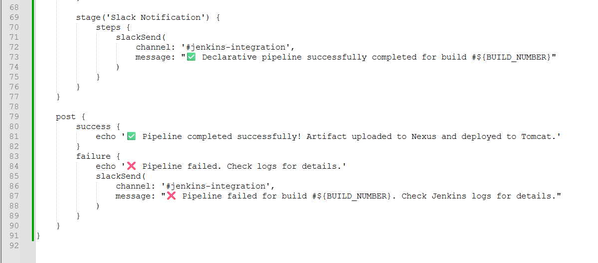
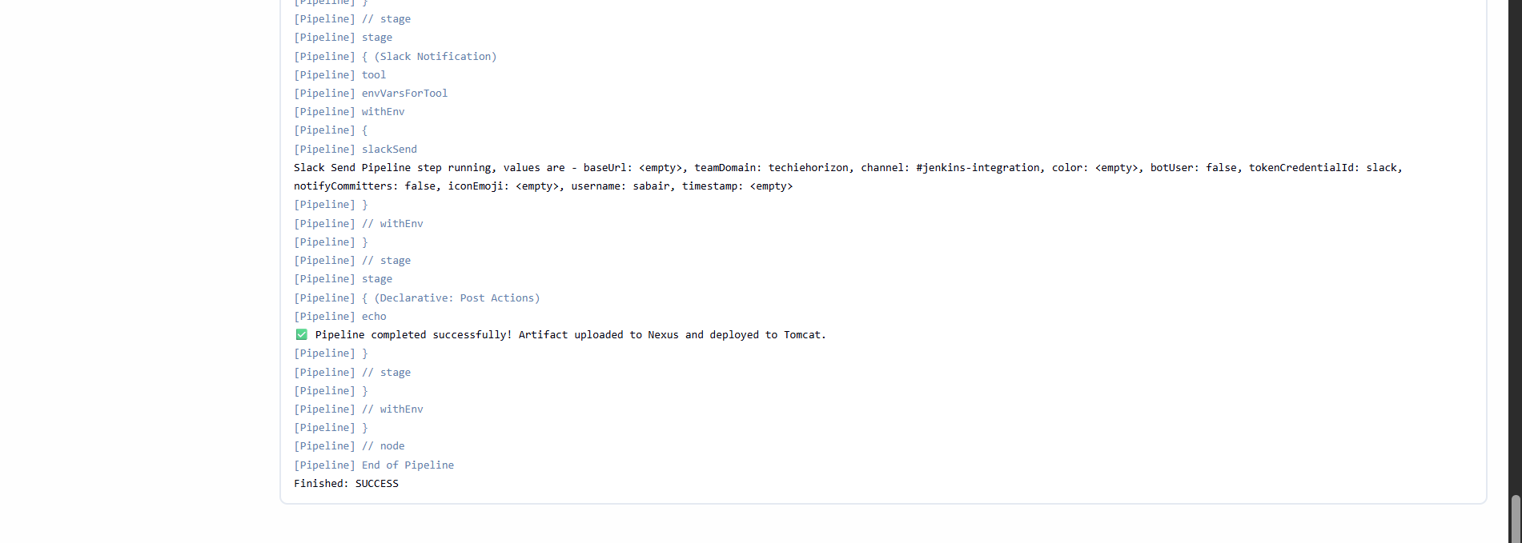
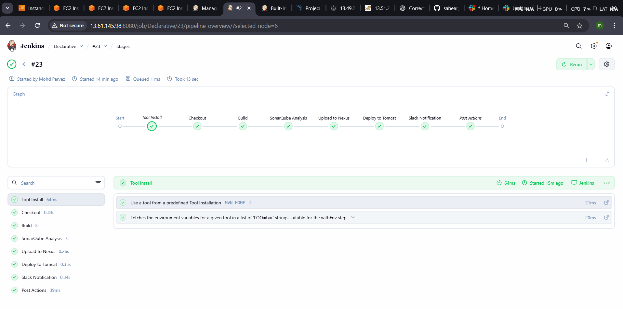
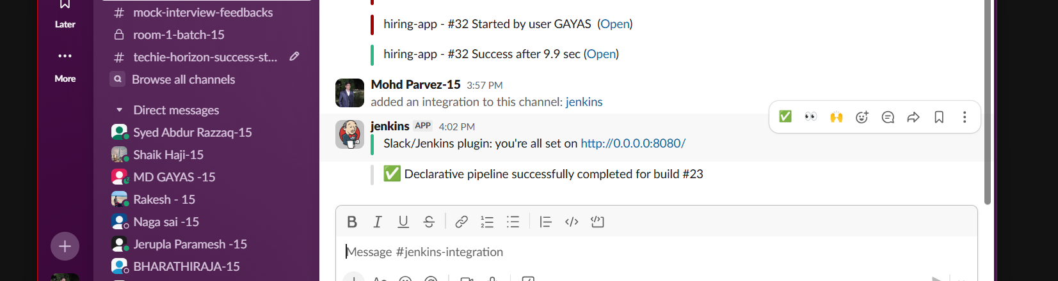

SCRIPTED PIPELINE
Setup a Jenkins CICD pipeline using Scripted pipeline using feature-1.1 branch. https://github.com/betawins/sabear_simplecutomerapp/tree/feature-1.1
stages:
Git Clone
node {

stage('Checkout') {
echo "Checking out source code from Git..."
git branch: 'master',
url: 'https://github.com/pmohd6065-ux/sabear_simplecutomerapp.git'
}
}
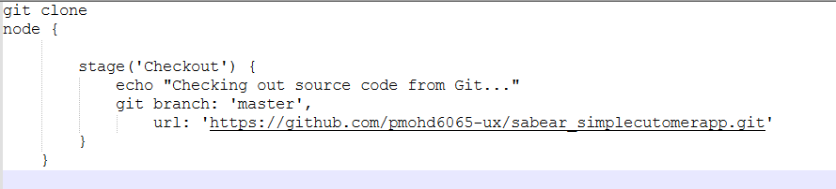
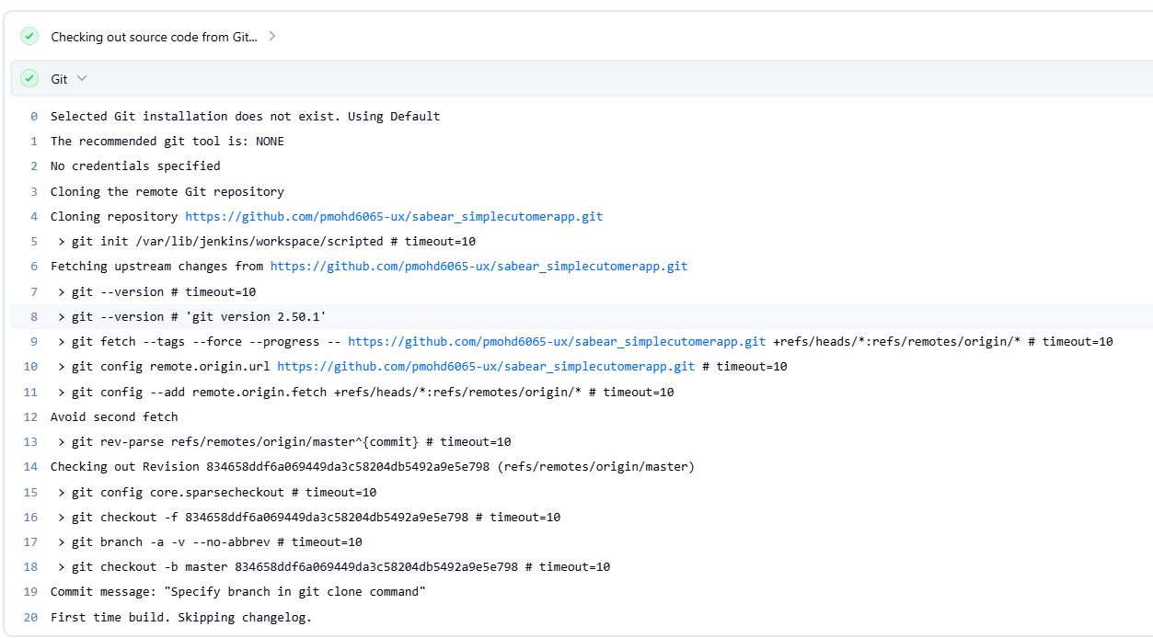

Maven Compilation
node {
// Define Maven environment
def mvnHome = tool 'MVN_HOME'

stage('Checkout') {
echo "Checking out source code from Git..."
git branch: 'master',
url: 'https://github.com/pmohd6065-ux/sabear_simplecutomerapp.git'
}

stage('Build') {
echo "Running Maven build..."
sh "${mvnHome}/bin/mvn clean install -f pom.xml"
}
}

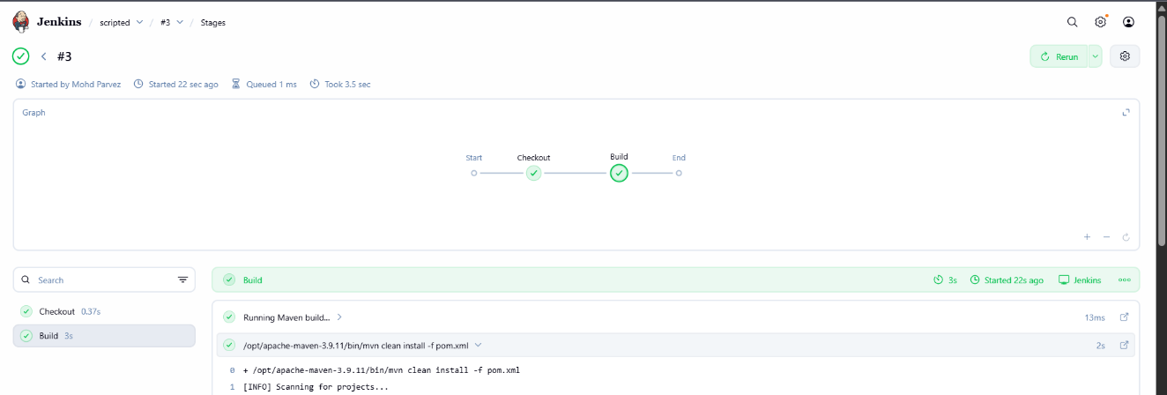

SonarQube Integration
node {
def mvnHome = tool 'MVN_HOME'

stage('Checkout') {
git branch: 'master',
url: 'https://github.com/pmohd6065-ux/sabear_simplecutomerapp.git'
}

stage('Build') {
sh "${mvnHome}/bin/mvn clean install -f pom.xml"
}

stage('SonarQubeAnalysis') {
withSonarQubeEnv('SonarQube') {
sh "${mvnHome}/bin/mvn sonar:sonar"
}
}
}

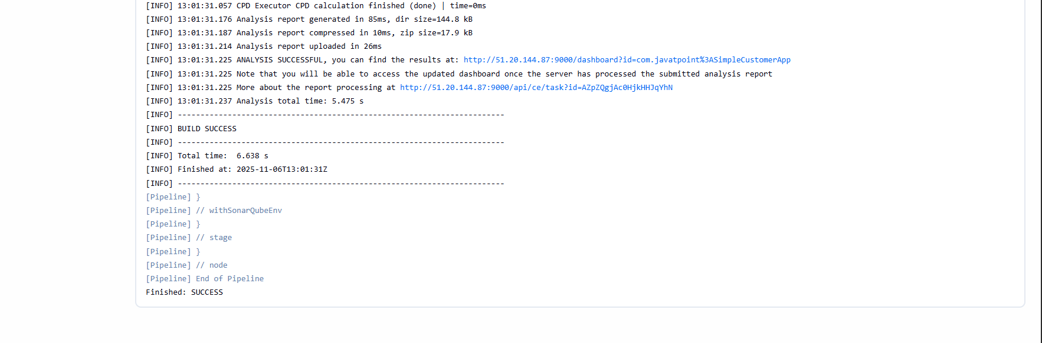
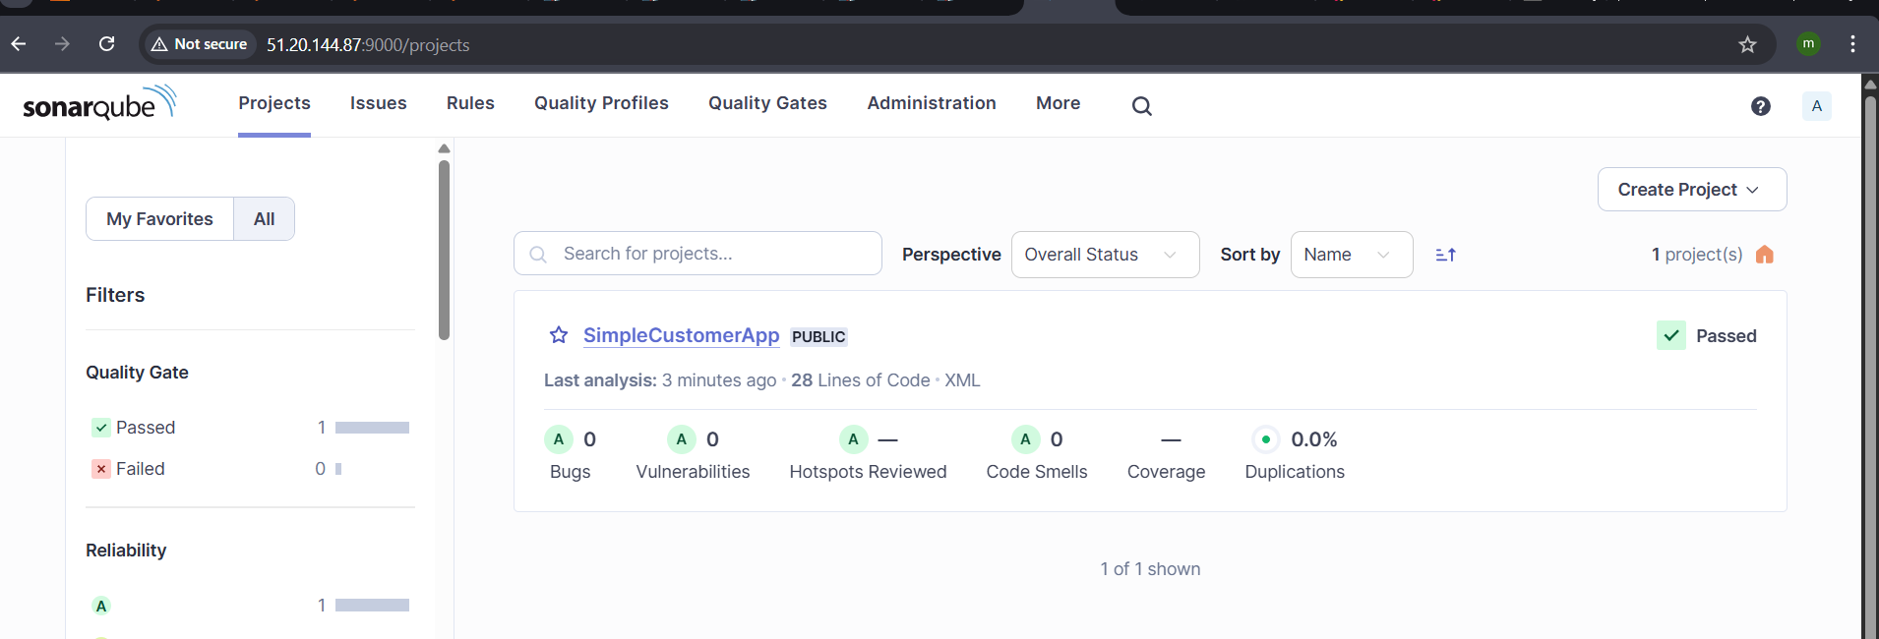
Nexus Artifactory
node {
def mvnHome = tool 'MVN_HOME'

stage('Checkout') {
git branch: 'master',
url: 'https://github.com/pmohd6065-ux/sabear_simplecutomerapp.git'
}

stage('Build') {
sh "${mvnHome}/bin/mvn clean install -f pom.xml"
}

stage('SonarQubeAnalysis') {
withSonarQubeEnv('SonarQube') {
sh "${mvnHome}/bin/mvn sonar:sonar"
}
}
stage('Upload to Nexus') {
nexusArtifactUploader(
artifacts: [[
artifactId: 'SimpleCustomerApp',
classifier: '',
file: "target/SimpleCustomerApp-${env.BUILD_NUMBER}-SNAPSHOT.war",
type: 'war'
]],
credentialsId: 'nexus',
groupId: 'com.javatpoint',
nexusUrl: '13.49.224.44:8081',
nexusVersion: 'nexus3',
protocol: 'http',
repository: 'feature',
version: "${env.BUILD_NUMBER}-SNAPSHOT"
)
}
}
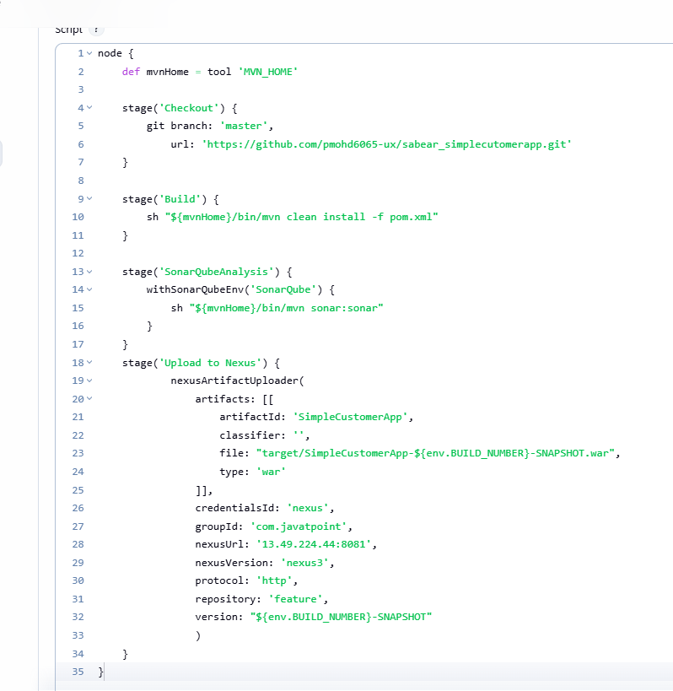
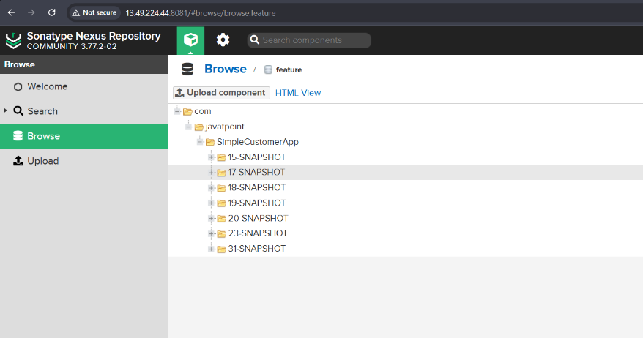
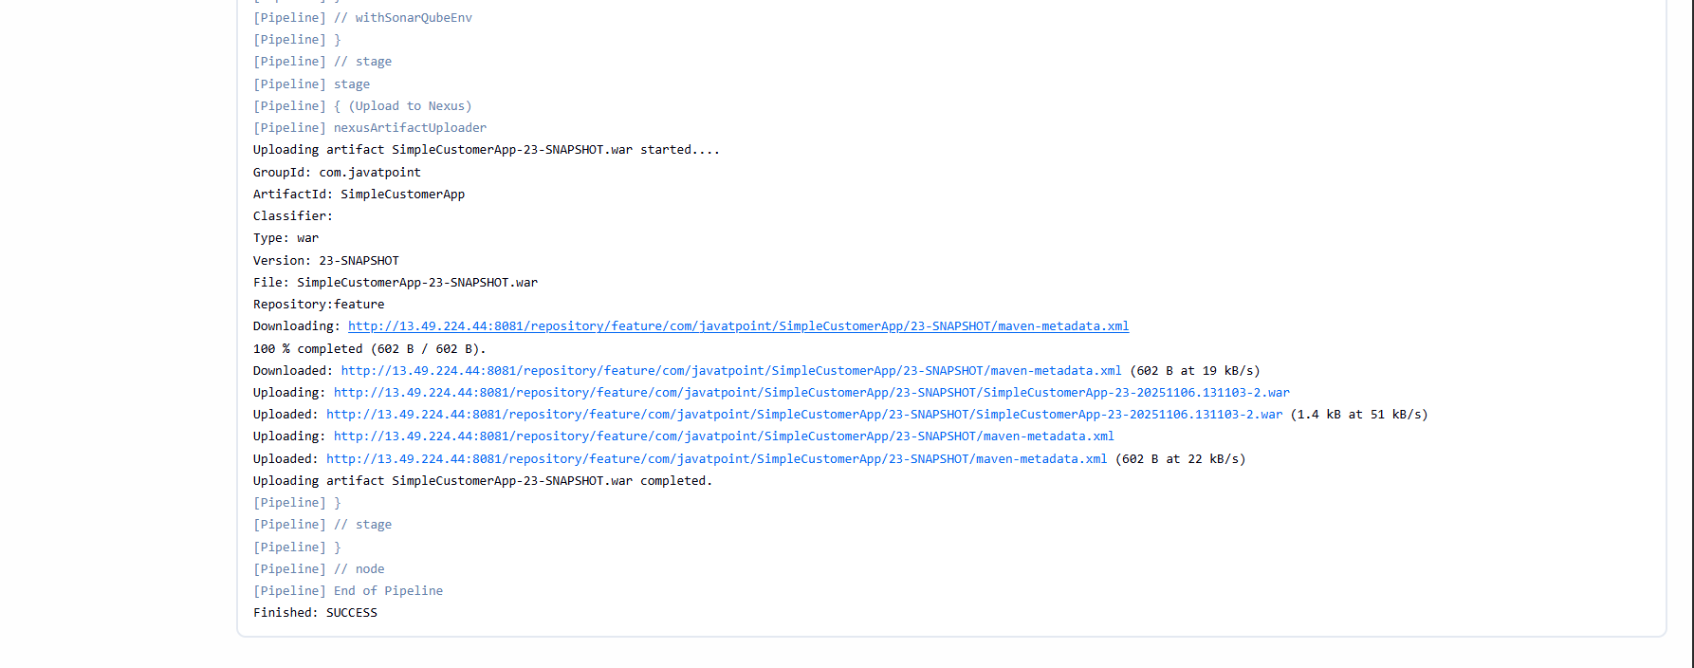
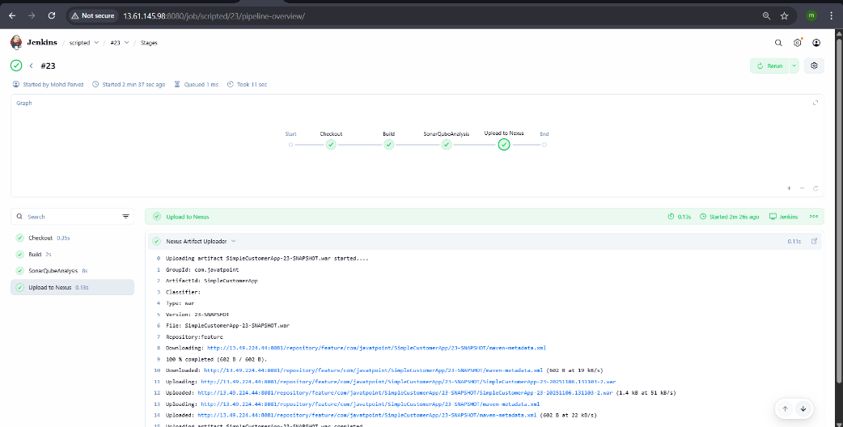


Deploy on tomcat
node {
def mvnHome = tool 'MVN_HOME'

stage('Checkout') {
git branch: 'master',
url: 'https://github.com/pmohd6065-ux/sabear_simplecutomerapp.git'
}

stage('Build') {
sh "${mvnHome}/bin/mvn clean package -f pom.xml"
}

stage('SonarQube Analysis') {
withSonarQubeEnv('SonarQube') {
sh "${mvnHome}/bin/mvn org.sonarsource.scanner.maven:sonar-maven-plugin:4.0.0.4121:sonar"
}
}

stage('Upload to Nexus') {
nexusArtifactUploader(
artifacts: [[
artifactId: 'SimpleCustomerApp',
classifier: '',
file: "target/SimpleCustomerApp-${env.BUILD_NUMBER}-SNAPSHOT.war",
type: 'war'
]],
credentialsId: 'nexus-server',
groupId: 'com.javatpoint',
nexusUrl: '13.51.159.64:8081',
nexusVersion: 'nexus3',
protocol: 'http',
repository: 'feature',
version: "${env.BUILD_NUMBER}-SNAPSHOT"
)
}
stage("Tomcat") {
deploy adapters: [tomcat9(alternativeDeploymentContext: '',
credentialsId: 'tomcat',
path: '', url: 'http://13.61.6.206:8080')],
contextPath: null,
war: '**/*.war'
}
}

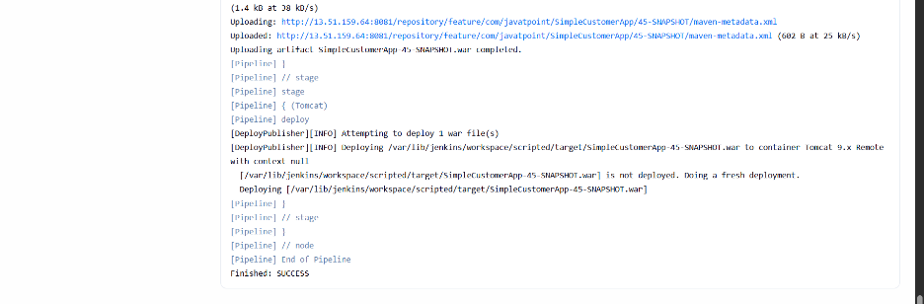

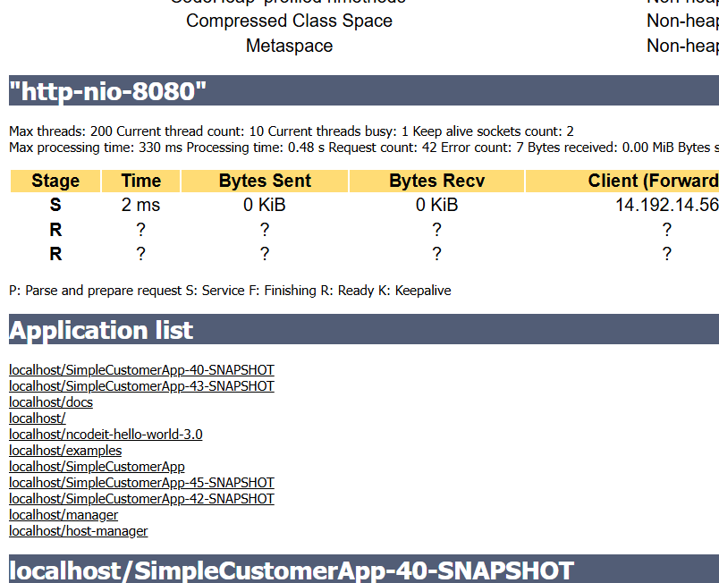
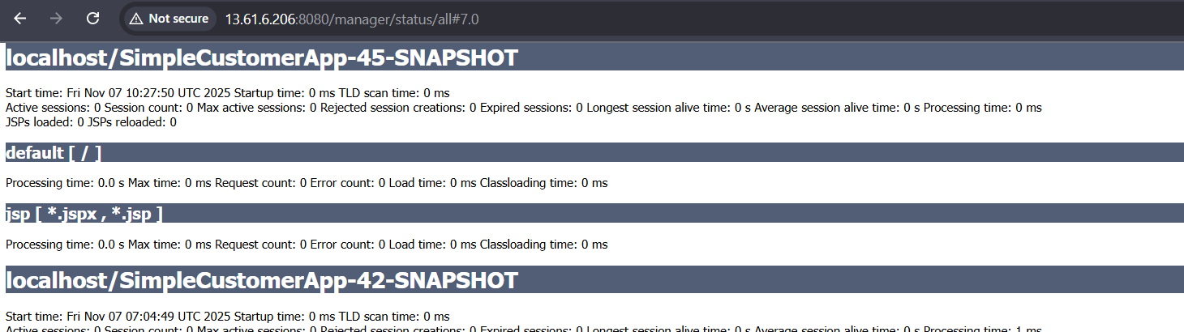

Slack Notification
node {
def mvnHome = tool 'MVN_HOME'

stage('Checkout') {
git branch: 'master',
url: 'https://github.com/pmohd6065-ux/sabear_simplecutomerapp.git'
}

stage('Build') {
sh "${mvnHome}/bin/mvn clean package -f pom.xml"
}

stage('SonarQube Analysis') {
withSonarQubeEnv('SonarQube') {
sh "${mvnHome}/bin/mvn org.sonarsource.scanner.maven:sonar-maven-plugin:4.0.0.4121:sonar"
}
}

stage('Upload to Nexus') {
nexusArtifactUploader(
artifacts: [[
artifactId: 'SimpleCustomerApp',
classifier: '',
file: "target/SimpleCustomerApp-${env.BUILD_NUMBER}-SNAPSHOT.war",
type: 'war'
]],
credentialsId: 'nexus-server',
groupId: 'com.javatpoint',
nexusUrl: '13.51.159.64:8081',
nexusVersion: 'nexus3',
protocol: 'http',
repository: 'feature',
version: "${env.BUILD_NUMBER}-SNAPSHOT"
)
}
stage("Tomcat") {
deploy adapters: [tomcat9(alternativeDeploymentContext: '',
credentialsId: 'tomcat',
path: '', url: 'http://13.61.6.206:8080')],
contextPath: null,
war: '**/*.war'
}
}
stage('slacknotification'){
slackSend channel: 'jenkins-integration',
message: 'completed scripted pipeline sucessfully mohdparvez',
tokenCredentialId: 'slack'
}
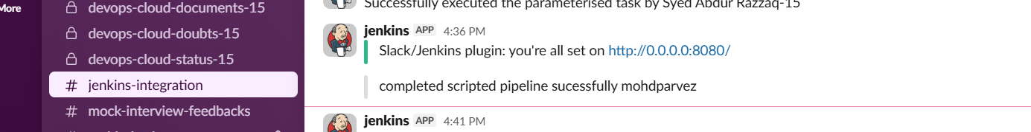

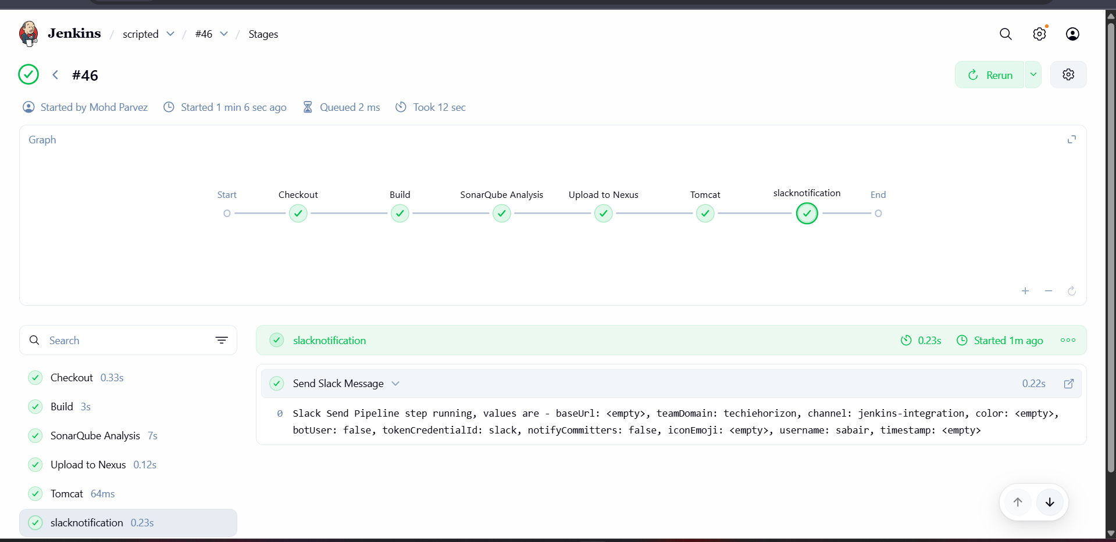

PARAMETERIZED PIPELINE
Create a parameterized job in Jenkins. https://github.com/betawins/spring3-mvc-maven-xml-hello-world-1.git

pipeline {
agent any

tools {
maven "MVN_HOME"
}

parameters {
string(name: 'GIT_REPO', defaultValue: 'https://github.com/betawins/sabear_simplecutomerapp.git', description: 'Git repository URL to clone')
string(name: 'SONAR_PROJECT_KEY', defaultValue: 'Ncodeit', description: 'SonarQube project key')
string(name: 'SONAR_PROJECT_NAME', defaultValue: 'Ncodeit', description: 'SonarQube project name')
string(name: 'SONAR_PROJECT_VERSION', defaultValue: '2.0', description: 'SonarQube project version')
string(name: 'NEXUS_URL', defaultValue: '18.221.189.193:8081/', description: 'Nexus server URL')
choice(name: 'NEXUS_VERSION', choices: ['nexus2', 'nexus3'], description: 'Select Nexus version')
choice(name: 'NEXUS_PROTOCOL', choices: ['http', 'https'], description: 'Nexus protocol type')
string(name: 'NEXUS_REPOSITORY', defaultValue: 'sonarqube', description: 'Nexus repository name')
string(name: 'NEXUS_CREDENTIAL_ID', defaultValue: 'nexus_keygen', description: 'Jenkins credential ID for Nexus authentication')
}

environment {
SCANNER_HOME = tool 'sonar_scanner'
}

stages {
stage("Clone Code") {
steps {
script {
git "${params.GIT_REPO}"
}
}
}

stage("Maven Build") {
steps {
script {
sh 'mvn -Dmaven.test.failure.ignore=true clean install'
}
}
}

stage("SonarQube Analysis") {
steps {
withSonarQubeEnv('sonarqube_server') {
sh """
\$SCANNER_HOME/bin/sonar-scanner \
-Dsonar.projectKey=${params.SONAR_PROJECT_KEY} \
-Dsonar.projectName=${params.SONAR_PROJECT_NAME} \
-Dsonar.projectVersion=${params.SONAR_PROJECT_VERSION} \
-Dsonar.sources=\$WORKSPACE/src/ \
-Dsonar.java.binaries=target/classes
"""
}
}
}

stage("Publish to Nexus") {
steps {
script {
def pom = readMavenPom file: "pom.xml"
def filesByGlob = findFiles(glob: "target/*.${pom.packaging}")
def artifactPath = filesByGlob[0].path

if (fileExists(artifactPath)) {
echo "*** Uploading artifact: ${artifactPath}"
nexusArtifactUploader(
nexusVersion: params.NEXUS_VERSION,
protocol: params.NEXUS_PROTOCOL,
nexusUrl: params.NEXUS_URL,
groupId: pom.groupId,
version: pom.version,
repository: params.NEXUS_REPOSITORY,
credentialsId: params.NEXUS_CREDENTIAL_ID,
artifacts: [
[artifactId: pom.artifactId, classifier: '', file: artifactPath, type: pom.packaging],
[artifactId: pom.artifactId, classifier: '', file: "pom.xml", type: "pom"]
]
)
} else {
error "*** File not found: ${artifactPath}"
}
}
}
}
}
}
stage("Tomcat") {
deploy adapters: [tomcat9(alternativeDeploymentContext: '',
credentialsId: 'tomcat',
path: '', url: 'http://13.61.6.206:8080')],
contextPath: null,
war: '**/*.war'
}